$49,000.00
EISEMANN – FIEDLER
3702 1ST AVE, SELBY
SELBY ORIGINAL LOTS 4 & 5 BLOCK 10
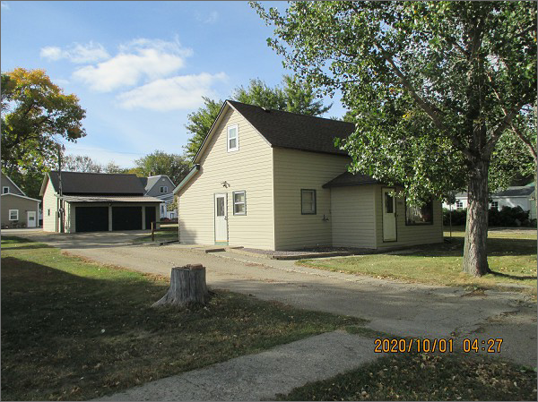
RECORD #4468

LOT SIZE 100’ X 140’ 1ST FLOOR 880 SQ FT
SINGLE FAMILY – ONE STORY (ATTIC) TOTAL LIVING 1088 SQ FT
AVERAGE QUALITY & CONDITION 3 BEDROOMS 1 BATH
BUILT IN 1930 KNEE WALL PORCH
2015; ROOF GOOD, VINYL SIDING WOOD DECK
WINDOW AIR, ALUM. WINDOWS GOOD STEPPING STONE PATIO
SOLD ON 6/02/20 FOR $49,000 DETACHED GARAGE 26’ X 29’
ASSESSED IN 2020 AT $33,890 10’ X 12’ SHED
SOLD ON 6/01/07 FOR $26,500
ASSESSED IN 2015 AT $25.675 RECORD # 4468

