$55,000.00
STOICK – KIHNE
MAIN ST. SELBY
SELBY ORIGINAL LOTS 1 THRU 3 BLOCK 4
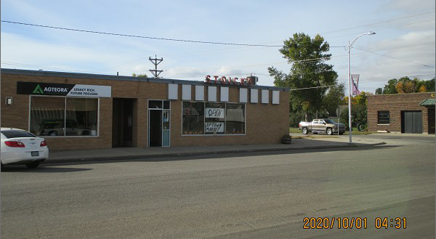
RECORD #4423

LOT SIZE 75’ X 140’
100% SUPERMARKET, 3800 SQ FT
TILE FLOOR, MASONRY BEARING WALLS
BUILT IN 1950’S, 38’ X 100’

SEPERATE BUILDING 100% STORAGE, 480 SQ FT. 20’ X 24’
WOOD OR STEEL FRAMED EXTERIOR WALLS

SOLD ON 8/28/20 FOR $55,000
ASSESSED IN 2020 AT $50,820
ASSESSED IN 2015 AT $50,820 RECORD #4423

