$134,900.00
LAFAVE – SALVERSON
3107 6TH AVE. SELBY
SELBY MILW LAND CO’S 2ND ADDN LOTS 10 & 11 BLOCK 28
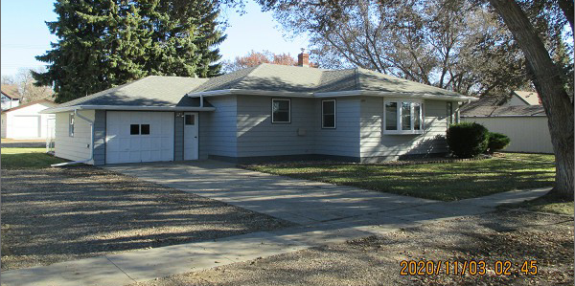
RECORD #4370

LOT SIZE 100’ X 140’ 1ST FLOOR 1342 SQ FT
SINGLE FAMILY – ONE STORY BASEMENT 1342 SQ FT
AVERAGE QUALITY & CONDITION 2 BEDROOMS ABOVE
BUILT IN 1955 1 BEDROOM BELOW
NATURAL GAS – CENTRAL AIR ATT. GARAGE 368 SQ FT
2002 NEW WINDOWS 12’ X 20’ GARDEN SHED
2015; ROOF GOOD, MASONITE
ALUM/ALUM WINDOWS
SCREEN PORCH EAST, SLIDING DOORS
SOLD ON 10/22/20 FOR $134,900
ASSESSED IN 2020 AT $106,330
ASSESSED IN 2015 AT $44,750 RECORD #4370

