$37,500.00
MCMULLEN – SCHNAIBLE
3207 CHICAGO ST. JAVA
JAVA MILW LAND CO’S 4TH ADDN LOT 4 & 5 BLOCK 27
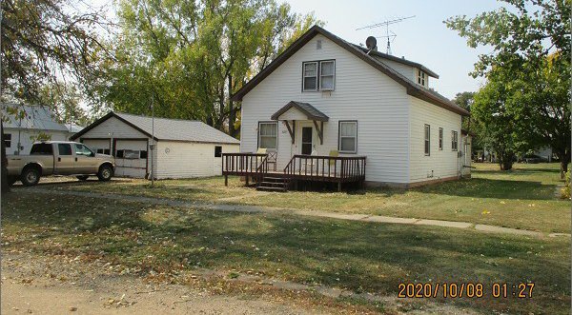
RECORD #4130

LOT SIZE 100’ X 146.54 GROUND FLOOR 972 SQ FT
SINGLE FAMILY - 1 ½ STORY TOTAL LIVING AREA 1458 SQ FT
FAIR CONDITION & QUALITY 3 BEDROOMS 1 ½ BATHS
BUILT IN 1946 DETACHED GARAGE 576 SQ FT
SOLD ON 8/20/20 FOR $37,500 WOOD DECK 8’ X 18’
ASSESSED IN 2020 AT $33,460
SOLD ON 8/16/16 FOR $43,000
ASSESSED IN 2017 AT $25,420 RECORD #4130

