$33,000.00
THORSTENSON – RICHARDS
6303 ST. PAUL ST. JAVA
JAVA MILW LAND CO’S 1ST ADDN LOTS 1 & 2 BLOCK 9
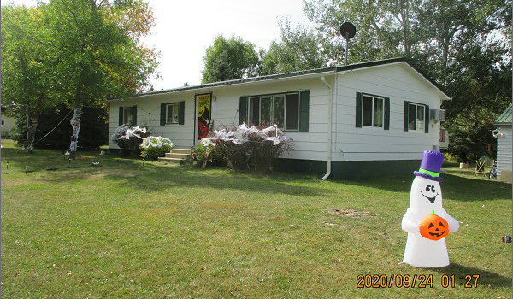
RECORD #4049

LOT SIZE 100’ X 140’ GROUND FLOOR 1152 SQ FT
SINGLE FAMILY – 1 STORY 3 BEDROOMS
AVERAGE QUALITY & CONDITION BASEMENT 1152 SQ FT
YEAR BUILT 1950 DETACHED GARAGE 992 SQ FT
SOLD ON 9/01/20 FOR $33,000 SOLID WALL PORCH 120 SQ FT
ASSESSED IN 2020 AT $13,000
SOLD ON 9/09/19 FOR $13,750 (AUCTION)
ASSESSED IN 2015 AT $14,200 RECORD #4049

