$80,000.00
SCHANZENBACH – KRAMER
SKINNER ST. AKASKA
AKASKA ORIGINAL LOT 15 BLOCK 15
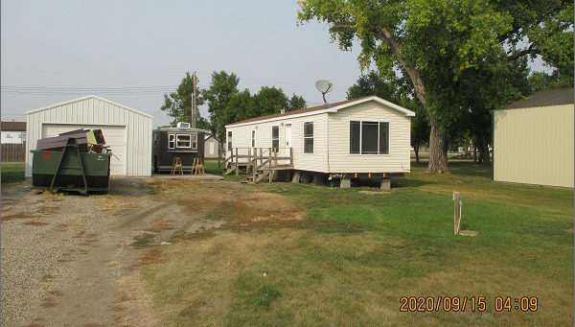
RECORD #3889

LOT SIZE 57.6’ X 132’ TOTAL LIVING AREA 784 SQ FT
MANUFACTURED HOME 1 FULL BATH
14’ X 56’ HIGHLAND CLASSIC CENTRAL AIR
BUILT IN 2009 DETACHED GARAGE 504 SQ FT
AVERAGE QUALITY & CONDITION
2016; ROOF GOOD, WINDOWS FAIR
SOLD ON 8/26/20 FOR $80,000
ASSESSED IN 2020 AT $50,620
SOLD IN 2011 FOR $65,000
ASSESSED IN 2015 AT $64,570 RECORD #3889

