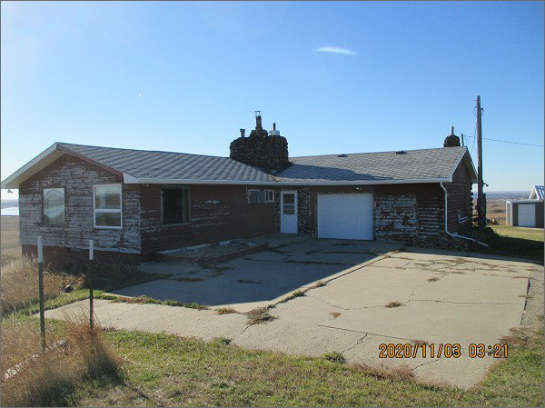
$250,000.00
PHILLIPS – WALTH
29125 SD HWY 1804
LOT 1 IN NW4SW4 25-124-79
RECORD #3697 & 8154

HOUSE TO BE REMOVED

62.82 TOTAL ACRES

2400 SQ FT METAL STORAGE BUILDING

ASSESSED IN 2020 AT $120,150
ASSESSED IN 2013 AT $104,795
59.25 ACRES ASSESSED AT $131,774

30’ X 45’ GARAGE BUILT IN 2006

