$410,000.00
OSTER – DADY
28730 127TH ST, MOBRIDGE
LOT 1 EXC LOT 2 AIRPORT 2ND SUBD IN SE4SW4 16-124-79
LOTS 1A, 2 & 3 TRACT 1 SE4SW4 16-124-79
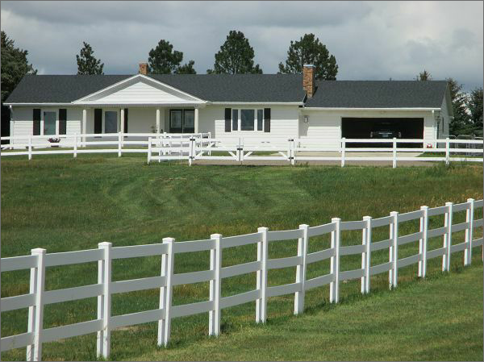
RECORD #3458

LOT SIZE 21.41 ACRES TOTAL LIVING 1644 SQ FT
SINGLE FAMILY ONE STORY FINISHED BSMT. 1644 SQ FT
AVERAGE QUALITY & CONDITION 3 BEDROOMS 2 BATHS
2015; FIREPLACE, ROOF GOOD, EGRESS NORTH
2 EGRESS WEST, DETACHED GARAGE ROOFED PORCH 156 SQ FT
ROOF GOOD, VINYL SIDING OPEN SLAB PORCH 392 SQ FT
BUILT IN 1973, CENTRAL AIR ATTACHED GARAGE 670 SQ FT
SOLD ON 10/5/20 FOR $410,000 DETACHED GARAGE 1,216 SQ FT
ASSESSED IN 2020 AT $292,110 GAZEBO
SOLD ON 7/31/17 FOR $380,000 RECORD # 3458
ASSESSED IN 2015 AT $134,015
SOLD ON 7/29/15 FOR $305,000, ASSESSED IN 2015 AT $134,015

