$140,000
BIG ISLAND ARMS INC – COUNTRYSIDE LLC
STR 22-121-75
E 317.19’ OF N 284.36’ IN THE NE4NE4 22-121-75
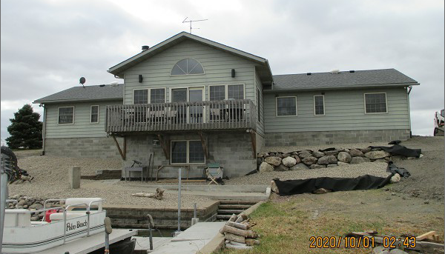
RECORD #281

2.07 ACRES
SINGLE FAMILY – 1 STORY
AVERAGE QUALITY & CONDITION
BUILT IN 1995 26’ X 74’ $138,000
TOTAL GROUND FLOOR 2,268 SQ FT
PLUMBING FIXTURES TOTAL 11 BASE 8
FINISHED BASEMENT 2,000 SQ FT
TOTAL BASEMENT 2,212 SQ FT
WOOD DECK 156 SQ FT
SOLD ON 6/15/20 FOR $140,000
ASSESSED IN 2020 AT $250,590
ASSESSED IN 2013 AT $217,905

