$264,900.00
SACKREITER – DAKOTA TERRITORY DEVELOPMENT
135 NORTH RIVERVIEW DRIVE, NEW EVARTS
LOT 20 & N 75’ OF LOT 21 IN REPLAT 29-123-78
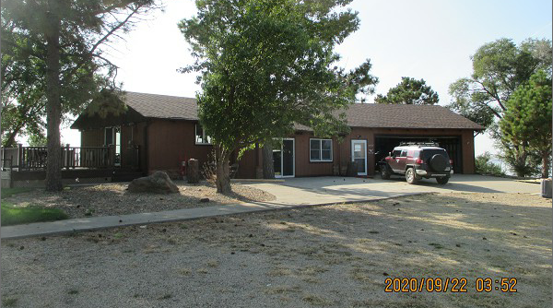
RECORD #2388

LOT SIZE 175’ X 200’ GROUND FLOOR 1104 SQ FT
SINGLE FAMILY – ONE STORY 3 BEDROOMS 2 BATHS
AVERAGE QUALITY & CONDITION BASEMENT LIVING 864 SQ FT
BUILT IN 1980 ATTACHED GARAGE 900 Q FT
2015; VERTICAL SIDING WOOD
WALK OUT BSMT/ SLIDING GLASS
LARGE COMPOSITE DECK 648 SQ FT
SOLD ON 9/01/20 FOR $264,900
ASSESSED IN 2020 AT $144,320
ASSESSED IN 2014 AT $110,945 RECORD #2388

