$65,000.00
TUMBLESON – BRIDGE CITY PROPERTIES
1301 NORTH MAIN ST. MOBRIDGE
MOBRIDGE THOMPSON’S OUTLOTS, LOT 18E
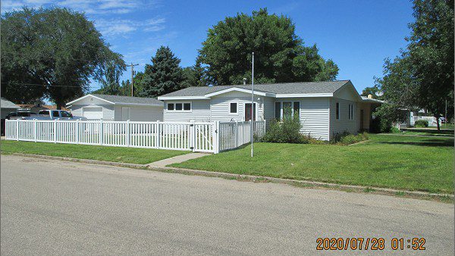
RECORD #6499

LOT SIZE 64’ X 150’ TOTAL LIVING AREA 1025 Q FT
SINGLE FAMILY – 1 STORY 2 BEDROOMS
AVERAGE QUALITY & CONDITION 1 FULL BATH
BUILT IN 1965 DETACHED GARAGE 432 SQ FT
2015; VINYL SIDING, ROOF GOOD SOLID WALL PORCH
VINYL/VINYL WINDOWS
CENTRAL AIR – NATURAL GAS
EXTERIOR HATCH DOOR TO BSMT
SOLD ON 7/14/2020 FOR $65,000
ASSESSED IN 2020 AT $82,380
ASSESSED IN 2020 AT $44,450 RECORD #6499

