$75,000.00
ZIMMERMAN – DINIZ
305 MAIN ST. MOBRIDGE
MOBRIDGE ORIGINAL LOT 10 BLOCK 3
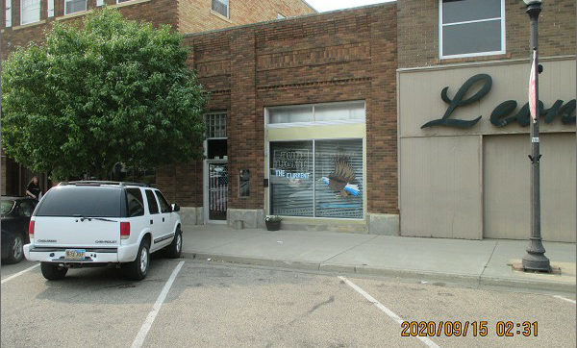
RECORD # 6248

LOT SIZE 25’ X 140’ 2347 SQ FT
100% RETAIL
LOW QUALITY CENTRAL AIR
AVERAGE CONDITION
ONE STORY
BUILT IN 1930
SOLD ON 6/04/20 FOR $75,000
ASSESSED IN 2020 AT $37,355
SOLD ON 1/14/09 FOR $25,000
ASSESSED IN 2012 AT $32,480 RECORD #6248

