$120,000.00
GLERUP – SADLER
909 8TH AVE WEST, MOBRIDGE
MOBRIDGE NWTS 3RD ADDN S. 35’ OF LOT 2 & N. 30’ OF LOT 3 BLK 29
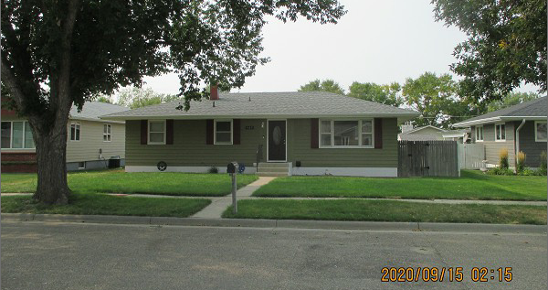
RECORD #6127

LOT SIZE 65’ X 120’ GROUND FLOOR 1104 SQ FT
SINGLE FAMILY – ONE STORY 3 BEDROOMS 1 ½ BATHS
AVERAGE QUALITY & CONDITION BASEMENT 1104 SQ FT
BUILT IN 1963 500 SQ FT FIN REC IN BSMT
2014; SHINGLES GOOD, SIDING POOR
BLOCK FND. CENTRAL AIR – NATURAL GAS
WINDOWS FAIR DETACHED GARAGE 672 SQ FT
SOLD ON 5/28/20 FOR $120,000
ASSESSED IN 2020 AT $96,230
SOLD ON 8/28/2017 FOR $106,500
ASSESSED IN 2015 AT $74,610
SOLD ON 9/17/12 $76,000 RECORD #6127
ASSESSED IN 2012 AT $56,895

