$131,400.00
ROESLER – CHANDLER
604 3RD AVE EAST, MOBRIDGE
MOBRIDGE GRAND CROSSING ADDN N 10’ OF LOT 4E & ALL OF LOT 4F BLOCK 61
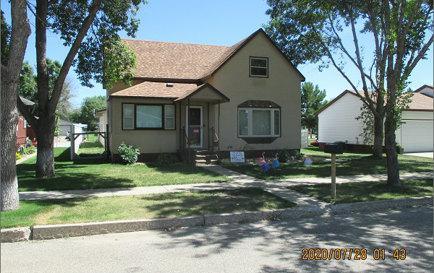
RECORD #5487

LOT SIZE 53’ X 140’ GROUND FLOOR 928 SQ FT
SINGLE FAMILY 1 ½ STORY TOTAL AREA 1232 SQ FT
AVERAGE QUALITY & CONDITION 3 BEDROOMS ABOVE
BUILT IN 1910 1 BEDROOM BELOW
2014; STUCCO, ROOF GOOD, WINDOW GOOD
NATURAL GAS, FOUNDATION FAIR 1 BATH 5 FIXTURES
SOLD ON 7/20/20 FOR $131400 DETACHED GARAGE 1936 SQ FT
ASSESSED IN 2020 AT $87,240 KNEE WALL PORCH 96 SQ FT
SOLD ON 6/13/18 $95,000 OPEN SLAB PORCH 336 SQ FT
ASSESSED IN 2018 AT $87,240
SOLD ON 1/12/06 FOR $65,000, ASSESSED IN 2006 AT $23,286

