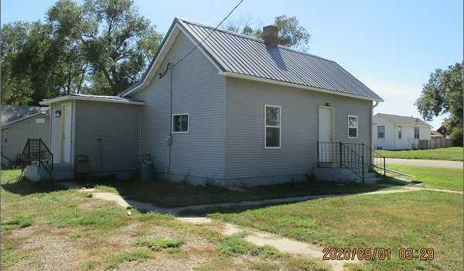
$42,500.00
TB PROPERTIES – HENDRICKSON
324 4TH ST WEST, MOBRIDGE
GRAND CROSSING ADDN W 65’ OF LOTS 11 & 12 & E 75’ OF LOTS 11 & 12 BLOCK 31
RECORD #’S 5254 & 5253

LOT SIZE 65’ X 100’ & 75’ X 100’ LIVING AREA 594 SQ FT
SINGLE FAMILY – ONE STORY 1 BEDROOM – 1 BATH
AVERAGE QUALITY & CONDITION 12’ X 16’ SHED
BUILT IN 1930 EGRESS WINDOW WEST
RECENT WINDOWS, SIDING & ROOFING
SOLD ON 6/04/20 FOR $42,500
ASSESSED IN 2019 AT $7,120
SOLD ON 9/26/2017 FOR $35,000
ASSESSED IN 2015 AT $7,120 RECORD #’S 5254 & 5253

