$135,000.00
RUEDEBUSCH – KREIN
22 EAST 5TH AVE. MOBRIDGE
MOBRIDGE EKLO’S 2ND ADDN LOTS 9C, 10A, 10B, 10C, 9F, 10D, 10F & 10E
1996 28’ X 80’ HIGHLAND MH
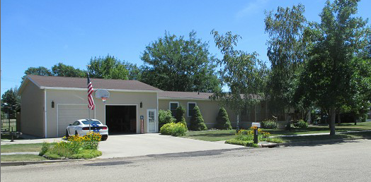
RECORD #’S 4964, 4967 & 4970
8 TOTAL LOTS TOTAL LIVING 2,128 SQ FT
SINGLE FAMILY – 1 STORY 4 BEDROOMS 2 ½ BATHS
AVERAGE QUALITY & CONDITION ATTACHED GARAGE 960 SQ FT
2014; SHINGLES FAIR, HARDBOARD SIDING DETACHED GARAGE 336 SQ FT
SLAB EAST COVERED, WOOD DECK-SLIDING GLASS GAZEBO 256 SQ FT
SOLD ON 7/09/20 FOR $135,000 COVERED SLAB 408 SQ FT
ASSESSED IN 2020 AT $75,210, IN 2012 AT $98,860 UTILITY SHED 96 SQ FT

RECORD #4964

