$25,000.00
GOETZ – NELMS
203 10TH AVE EAST, MOBRIDGE
MOBRIDGE DRAEGER’S 1ST ADDN LOT 6 BLOCK 10
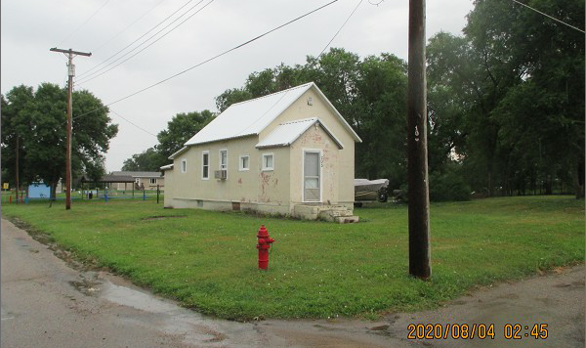
RECORD #4838

LOT SIZE 50’ X 140’ LIVING AREA 576 SQ FT
SINGLE FAMILY – 1 STORY 1 BEDROOM 1 ½ BATHS
FAIR QUALITY & CONDITION SOLID WALL PORCH 94 SQ FT
BUILT IN 1940 + - BASEMENT 432 SQ FT
2014; STUCCO, CASEMENT WINDOWS POOR
LARGE FOUNDATION CRACKS, STEEL ROOF
SOLD ON 7/03/2020 FOR $25,000
ASSESSED IN 2020 AT $21,120
ASSESSED IN 2012 AT $8,170 RECORD #4838

