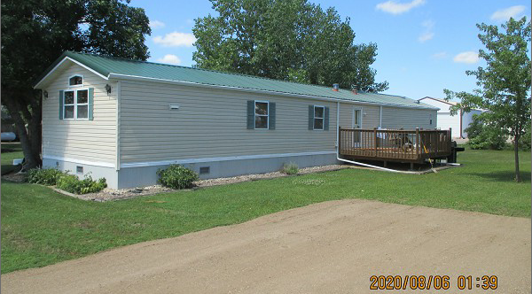
$90,000.00
SCHNAIDT – HOUCK/FEIST
202 COFFEY ST. AKASKA
AKASKA ORIGINAL LOTS 8, 9 & 10
1997 SKYLINE 16’ X 76’
RECORD #3823

3 LOTS (57.6’ X 132’ PER LOT) LIVING AREA 1216 SQ FT
MANUFACTURED HOME 3 BEDROOMS 1 ½ BATHS
BUILT IN 1997
2011; NEW DECK, STEEL ROOF $5,000
2016; DECK ON EAST, METAL ROOF
CENTRAL AIR, PROPANE, DECK ON WEST
WEB WATER
SOLD ON 7/29/2020 FOR $90,000
3 LOTS PLUS TRAILER ASSESSED AT $52,670 IN 2020

