$312,000.00
WELLS FOUNDATION INC. – SCHNEIDER
1816 KENNEDY DRIVE, MOBRIDGE
MOBRIDGE SHOR ACRES LOT 96
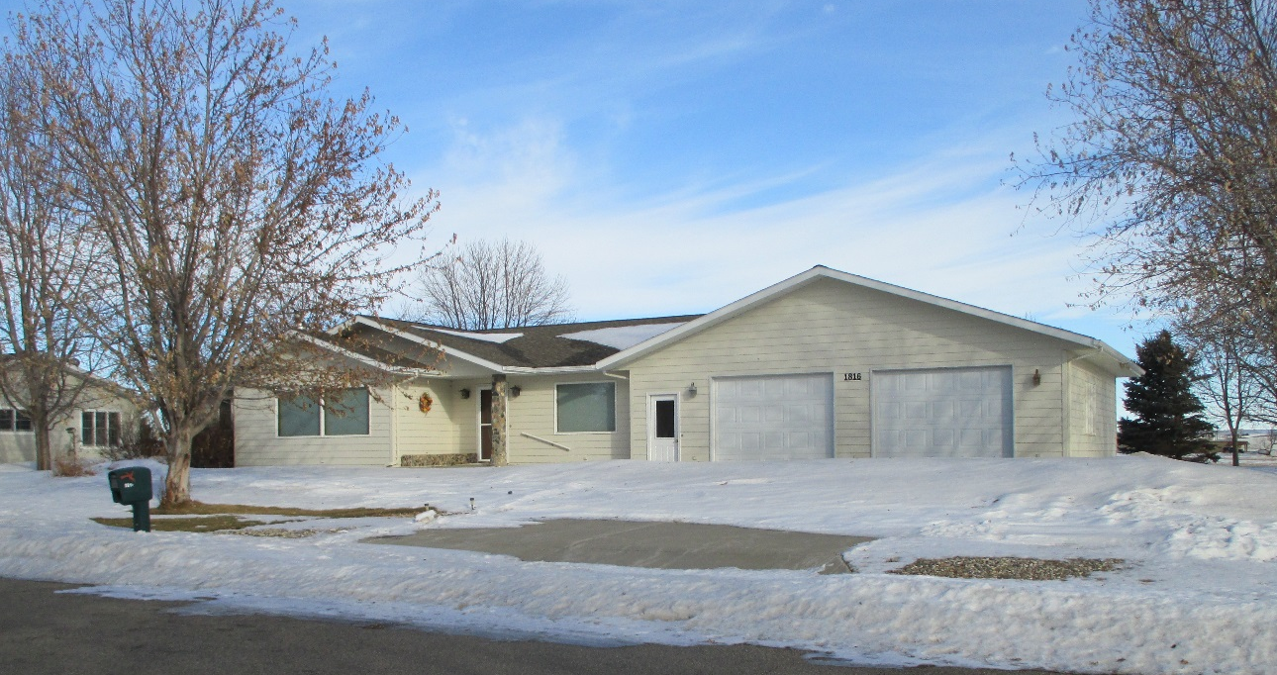
RECORD #7478

LOT SIZE 120.2’ X 142.5’ GROUND FLOOR 1952 SQ FT
SINGLE – FAMILY ONE – STORY BASEMENT 1952 SQ FT
AVERAGE QUALITY & CONDITION ALL OF BASEMENT LIVING
BUILT IN 1999 1 BEDROOM ABOVE 3 BELOW
CENTRAL-AIR NATURAL-GAS 2 FULL BATHS 2 HALF BATHS
2014; SLIDING GLASS DOOR, POURED FDN. ATTACHED GARAGE 1056 SQ FT
SUNKEN WINDOW WELLS CONCRETE PATIO 406 SQ FT
CEMENT BOARD SIDING/SHINGLES GARDEN SHED 10’ X 12’
SOLD ON 9/18/19 FOR $312,000
ASSESSED IN 2019 AT $294,40
SOLD IN 2014 FOR $225,000
ASSESSED IN 2014 AT $252,095 RECORD #7478

