$200,000.00
DROOG – BROCKEL
1710 EAST GRAND CROSSING, MOBRIDGE
MOBRIDGE REPLAT IN W2S2SE4 20-124-79 LOTS 2, 3, 4 & 5 AND VACATED STREET BETWEEN LOTS 1 & 2
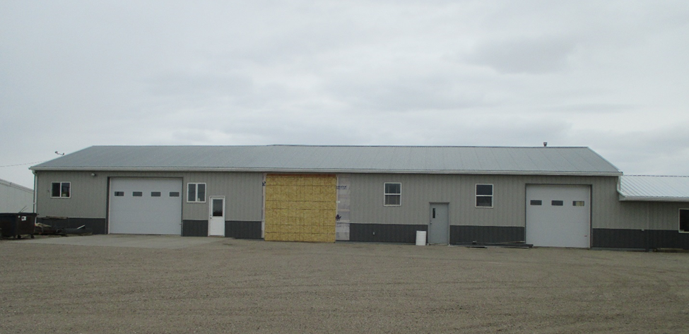
RECORDS #6561 & #3614

1.45 ACRES ALSO INCLUDED 1.14 ACRES
12% OFFICE ( S2E2 OF LOT 10 SUBD. OF
88% REPAIR GARAGE E2SE4 20-124-79)
STEEL ON STEEL FRAME
HVAC HEATING
Re-ROOFED IN 2005 & LEANTO $10,000
4708 TOTAL SQ FT
GARAGE 3600 SQ FT
OFFICE 500 SQ FT
SOLD ON 3/3/20 FOR $200,000
ASSESSED IN 2020 AT $64,025
ASSESSED IN 2012 AT $51,150 RECORDS #6561 & 3614

