$165,000.00
KUHN – SCHOTT
914 9TH AVE WEST, MOBRIDGE
MOBRIDGE NWTS CO’S 3RD ADDN LOTS 9 & 10 BLOCK 29
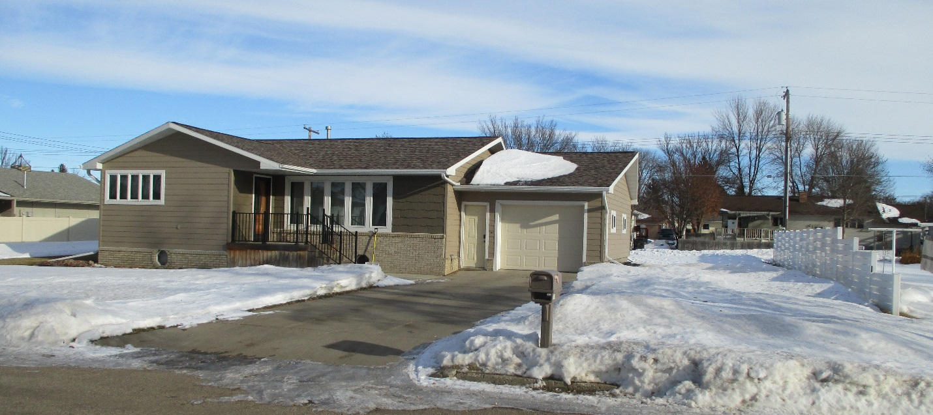
RECORD #6133

LOT SIZE 100’ X 120’ GROUND FLOOR 1024 SQ FT
SINGLE-FAMILY ONE-STORY BASEMENT LIVING 1024 SQ FT
AVERAGE QUALITY & CONDITION 2 BEDROOMS ABOVE 1 BELOW
BUILT IN 1965 2 ½ BATHS
CENTRAL AIR-NATURAL GAS ATTACHED GARAGE 416 SQ FT
2014; BRICK FACE, WINDOWS GOOD WOOD DECK 480 SQ FT
CEMENT BOARD FABRICATED SHAKES
ABOVE ROCK FACE COVERED FRONT DOOR
SOLD ON 12/4/2019 FOR $165,000
ASSESSED IN 2019 AT $135,840 1991 MOVED HOUSE FROM SELBY
SOLD IN 2016 FOR $135,000 NEW BASEMENT 1991
ASSESSED IN 2014 AT $100.765 RECORD #6133

