$150,000.00
FRYLING HUNNEL
1005 4TH AVE WEST, MOBRIDGE
MOBRIDGE NWTS 1ST ADDN S. 42.5’ OF LOT 4 & N 17.5’ OF LOT 5 BLOCK 3
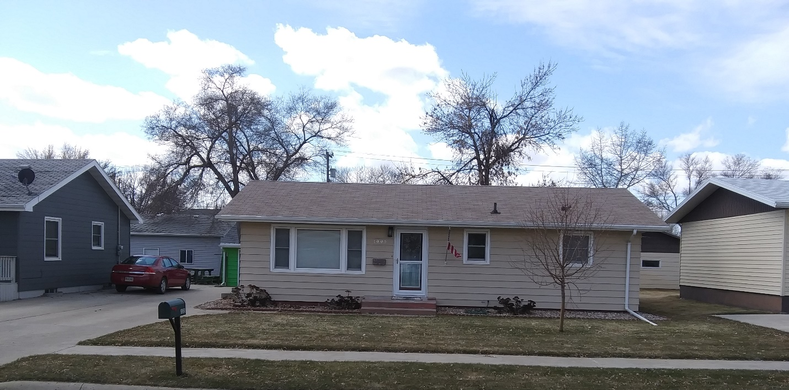
RECORD #5922

LOT SIZE 60’ X 140’ GROUND FLOOR 1025 SQ FT
SINGLE FAMILY – ONE STORY 4 BEDROOMS 2 UP, 2 DOWN
AVERAGE QUALITY & CONDITION 2 ½ BATHS
BUILT IN 1965 + - BASEMENT 1025 SQ FT
CENTARL AIR – NATURAL GAS 500 SQ FT FINISHED REC.
2014; SHINGLES FAIR, WINDOWS FAIR DETACHED GARAGE 864 SQ FT
2001; SPRINKLER SYSTEM WOOD DECK 196 SQ FT
SOLD ON 3/12/20 FOR $150,000 SHED 10’ X 11’
ASSESSED IN 2019 AT $120,120
SOLD 6/2/17 FOR $149,000
ASSESSED IN 2014 AT $107,750 RECORD #5922

