$108,709.00
BARTON – DUCHENEAUX
317 2ND AVE WEST, MOBRIDGE
MOBRIDGE MILW LAND CO’S 1ST ADDN LOT 2 BLOCK 25
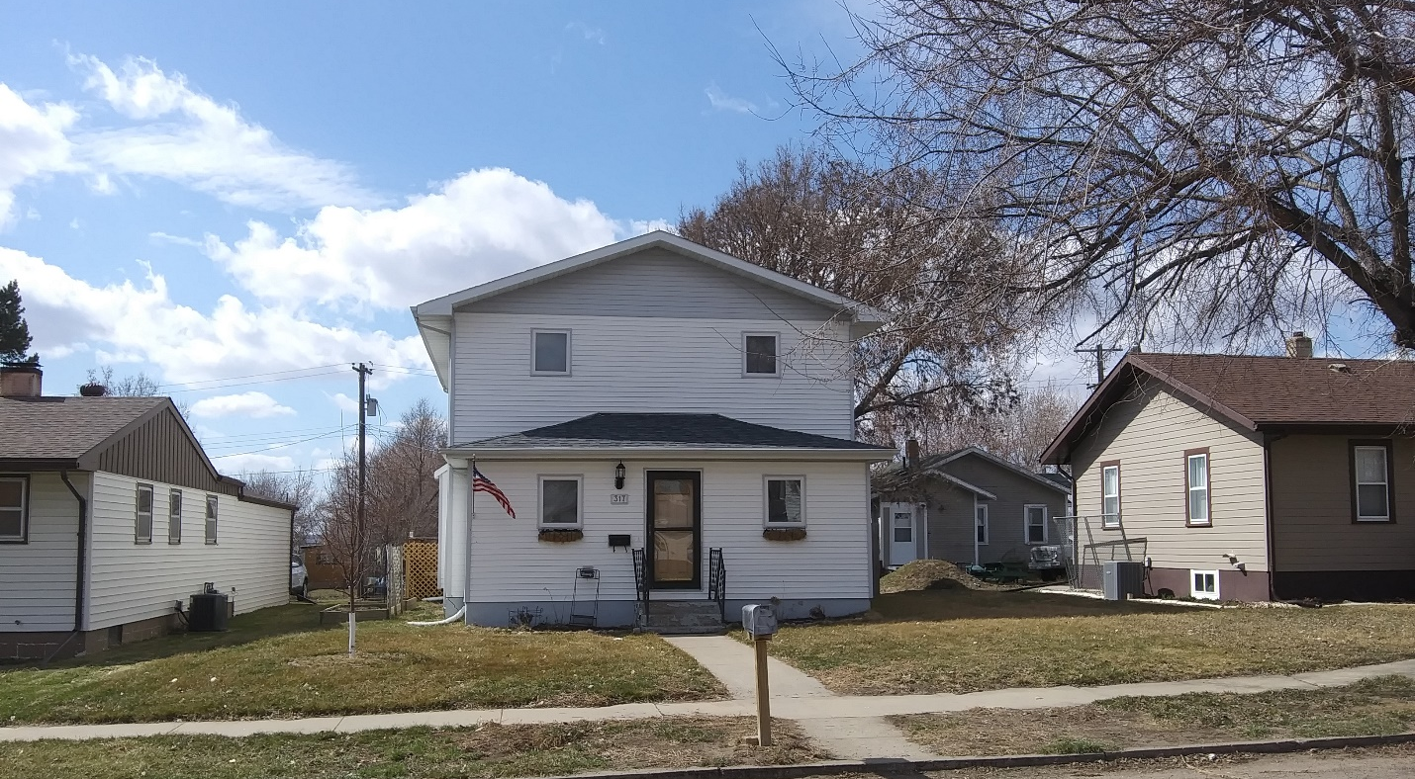
RECORD #5836

LOT SIZE 50’ X 140’ TOTAL LIVING AREA 2256 SQ FT
SINGLE FAMILY – 2 STORY GROUND FLOOR 1192 SQ FT
AVERAGE CONDITION & QUALITY 5 BEDROOMS - 2 ½ BATHS
BUILT IN 1912 BASEMENT 1064 SQ FT
2015; VINYL SIDING, WINDOWS NEWER KNEE WALL PORCH 192 SQ FT
CENTRAL AIR - NATURAL GAS WOOD DECK 280 SQ FT
1997; ADD 2ND STORY TO HOUSE METAL GARDEN SHED
SOLD ON 12/18/19 FOR $108,709
ASSESSED IN 2019 AT $69,000
SOLD 7/26/2013 FOR $69,000
ASSESSED IN 2013 AT $51,674 RECORD #5836

