$190,000.00
BRYANT/LASHMET – VERHULST
403 10TH ST EAST, MOBRIDGE
MOBRIDGE MAIN PARK N 10’ OF LOT 14 & ALL LOTS 15 & 16 BLOCK 3
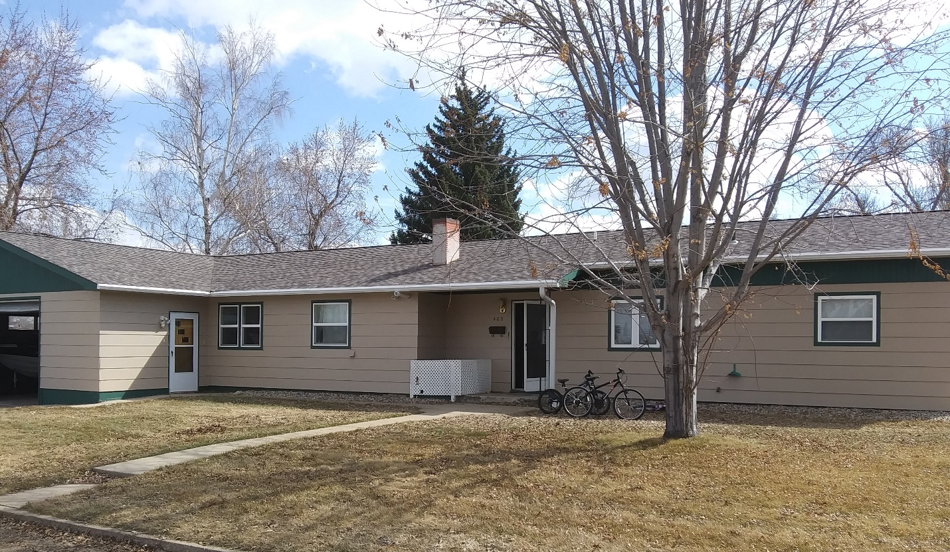
RECORD #5567

LOT SIZE 85’ X 142’ GROUND FLOOR 1906 SQ FT
SINGLE FAMILY–ONE STORY 3 BEDROOMS ABOVE
AVERAGE QUALITY & CONDITION 1 BEDROOM BASEMENT
BUILT IN 1965 2 FULL BATHS, ONE HALF BATH
2014; ROOF GOOD, WINDOWS GOOD BASEMENT 480 SQ FT
NATURAL GAS, LARGE EGRESS 350 SQ FT FINISHED LIVING
SOLD ON 3/6/20 FOR $190,000 GARAGE 960 SQ FT
ASSESSED IN 2019 AT $157,250 ROOFED PORCH 44 SQ FT
SOLD ON 2/9/18 FOR $187,500 KNEE WALL PORCH 128 SQ FT
ASSESSED IN 2014 AT $125,000 OPEN SLAB PORCH 176 SQ FT
SOLD 11/07/11 FOR $125,000
RECORD #5567

