QUENZER – FRYHLING
$170,000.00
609 2ND AVE WEST, MOBRIDGE
MOBRIDGE GRAND CROSSING ADDN LOTS 3, 4 & 5A BLOCK 47
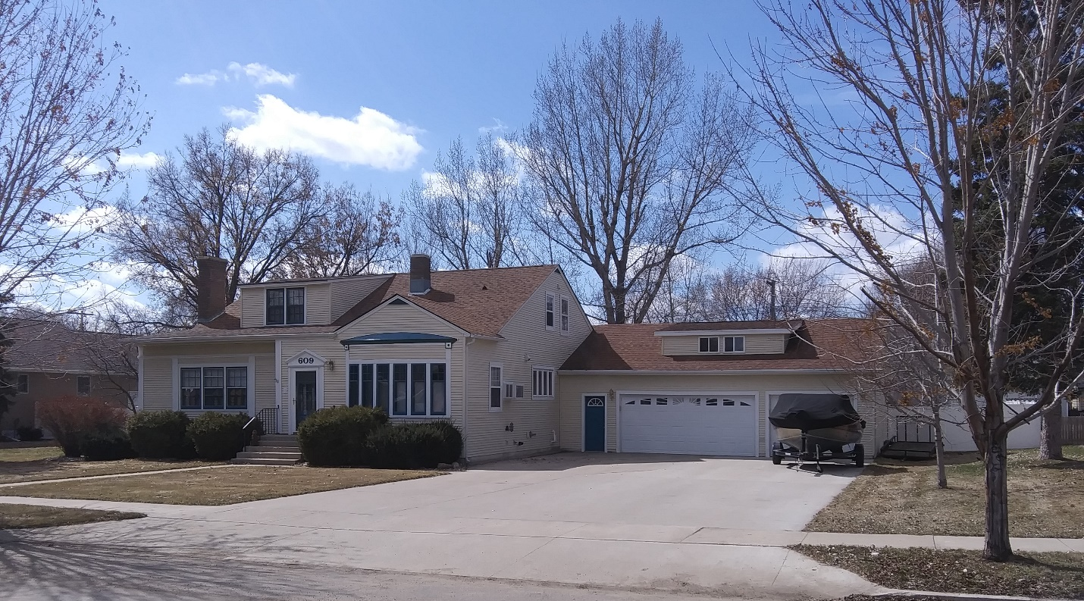
RECORD #5361

LOT SIZE 125’ X 140’ TOTAL LIVING AREA 2,754 SQ FT
SINGLE FAMILY 1ST FLOOR 1,850 SQ FT
1 ½ STORY BASEMENT 1,208 SQ FT/900 SQ FT FIN
AVERAGE QUALITY & CONDITION ATTACHED GARAGE 864 SQ FT
BUILT IN 1927 6 BEDROOMS 3 BATHS
NATURAL GAS – WINDOW AIR FIREPLACE
BACKYARD ROCK WALL & BARBECUE 2014; SOME NEWER WINDOWS
SOLD ON 3/13/20 FOR $170,000 VINYL SIDING
ASSESSED IN 2019 AT $169,570 GOOD FOUNDATION
SOLD 11/7/14 FOR $165,000; 7/25/06 FOR $135,000
ASSESSED IN 2014 AT $140,510
ASSESSED IN 2012 AT $121,185 RECORD #5361

