$24,000.00
RIPLEY – KELLER
518 N MAIN, MOBRIDGE
MOBRIDGE GRAND CROSSING ADDN LOTS 17 & 18 BLOCK 42
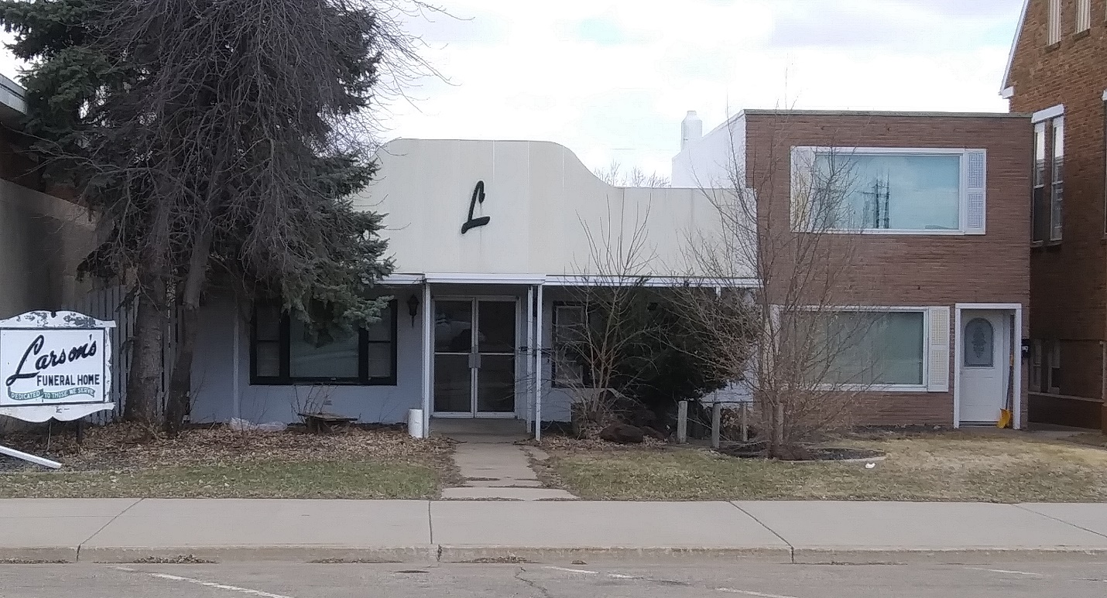
RECORD #5331

LOT SIZE 50’ X 150’ TOTAL AREA 5,040 SQ FT
ONE STORY
AVERAGE QUALITY & CONDITION
BUILT IN 1960 + -
79% MORTUARY
21% MIXED RETAIL W/RESID. UNITS
MASONRY WALLS
SOLD ON 3/11/2020 FOR $24,000
ASSESSED IN 2019 AT $105,845
ASSESSED IN 2012 AT $92,040 RECORD #5331

