$116,900.00
SDMN PROPERTIES LLC – BRIDGE CITY PROPERTIES
503 WEST GRAND CROSSING, MOBRIDGE
MOBRIDGE GRAND CROSSING ADDN. LOT 1 & 2 BLK 30
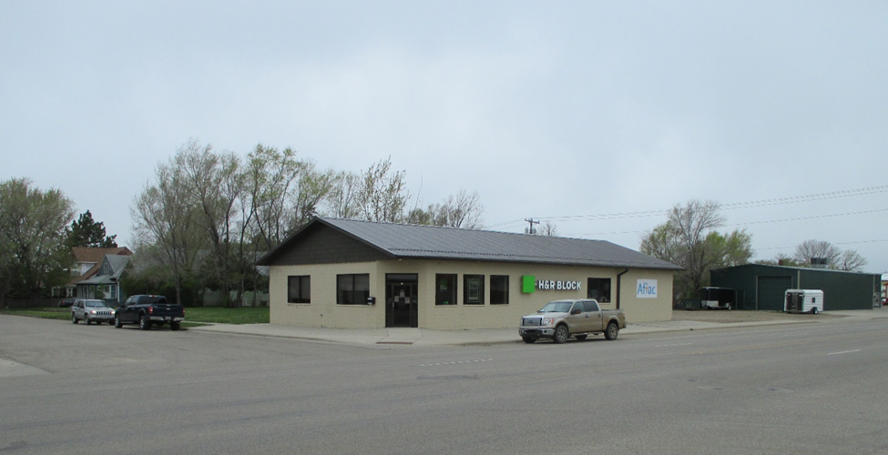
RECORD #5231

LOT SIZE 140’ X 100’ TOTAL FLOOR AREA 3182 SQ FT
100% OFFICE BUILDING HVAC HEATING
MASONRY BEARING WALLS
1986; REMODEL, 1988; NEW HEATING & AIR
2007; INTERIOR REMODEL $15,000
2008; INTERIOR REMODEL, NEW FURNACE & AIR
REPLACED INTERIOR WALLS, CEILING $40,000
SOLD ON 5/6/20 FOR $116,900
ASSESSED IN 2020 AT $133,890
SOLD ON 2/22/2007 FOR $80,000
ASSESSED IN 2010 AT $81,380 RECORD #5231

