$177,500.00
BALLIET – DUPPER
1204 SUNSET DRIVE, MOBRIDGE
MOBRIDGE BEL AIRE 2ND ADDN 2ND SUBDIVISION LOT 22 BLOCK 2
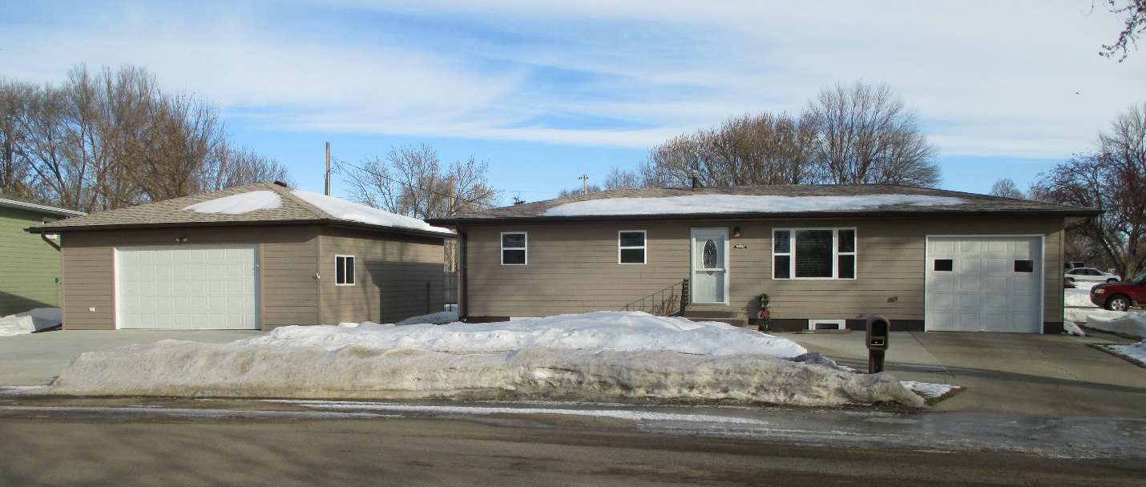
RECORD # 4750

LOT SIZE 75’ X 130’ TOTAL LIVING AREA 960 SQ FT
SINGLE-FAMILY ONE-STORY BASEMENT 960 SQ FT 350’ LIVING
AVERAGE QUALITY & CONDITION 3 BEDROOMS ABOVE 1 BELOW
BUILT IN 1955 1 FULL BATH, ONE ½ BATH
NATURAL GAS CENTRAL AIR ONE ¾ BATH
2014; COMPLETELY REMODELED, REWIRED 2016 DET. GARAGE 28’ X 30’
NEW FURNACE, NEW WINDOWS, SIDING ATTACHED GARAGE 12’ X 24’
2 EGRESS, NO ALLEY ACCESS WOOD DECK 144 SQ FT
SOLD ON 9/27/19 FOR $177,500
ASSESSED IN 2019 AT $136,500
SOLD IN 2015 FOR $135,000
SOLD IN 2013 FOR $60,500
ASSESSED IN 2016 AT 108,460
ASSESSED IN 2012 AT $53,375 RECORD # 4750

