$170,000.00
WUDEL – MUNKVOLD
3603 2ND AVE, SELBY
SELBY ORIGINAL LOTS 7 & 8 & S ½ OF LOT 9 BLOCK 10
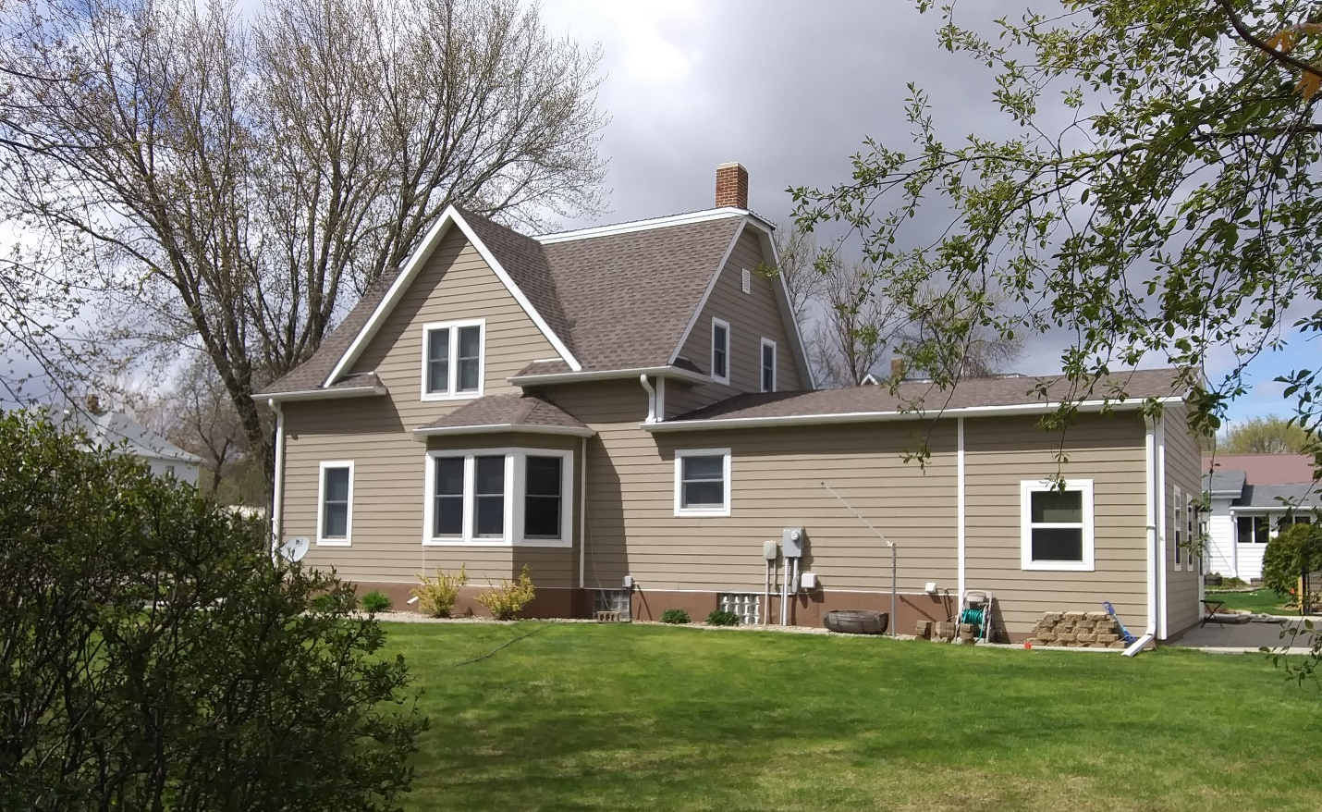
RECORD #4470

LOT SIZE 125’ X 140’ GROUND FLOOR 1056 SQ FT
SINGLE FAMILY – 1 ½ STORY TOTAL AREA 1440 SQ FT
AVERAGE QUALITY & CONDITION 4 BEDROOMS - 2 ½ BATHS
BUILT IN 1910 BASEMENT 1032 SQ FT
2011; 8’ X 24’ ADDITION $40,000 BASEMENT 500 SQ FT FINISHED
2012; 40’ X 47’ GARAGE ROOFED PORCH 40 SQ FT
2013; SHINGLE HOUSE – GARAGE $15,000 SOLID WALL PORCH 120 SQ FT
2015; ROOF & WINDOWS GOOD KNEE WALL PORCH 150 SQ FT
SOLD ON 2/14/20 FOR $170,000 OPEN SLAB PORCH 370 SQ FT
ASSESSED IN 2020 AT $132,380 2 STALL GARAGE 1,880 SQ FT
SOLD ON 6/04/2012 FOR $145,000
ASSESSED IN 2014 AT $70,095 RECORD #4470

