$61,500.00
MUNKVOLD – PATENEAUDE
3204 5TH AVE, SELBY
SELBY MILW LAND CO’S 2ND ADDN LOT 4 & N ½ OF LOT 5 BLOCK 28
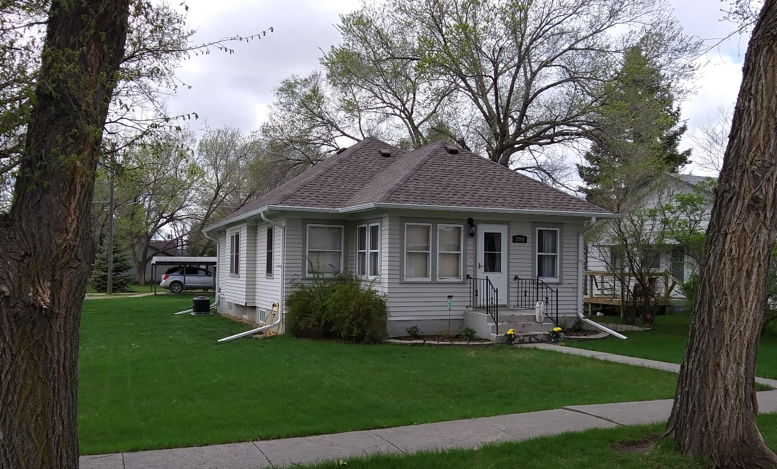
RECORD #4366

LOT SIZE 75’ X 140’ TOTAL LIVING 1020 SQ FT
SINGLE FAMILY – ONE STORY 2 BEDROOMS 1 ½ BATHS
FAIR QUALITY & CONDITION BASEMENT 1008 SQ FT
BUILT IN 1920 DETACHED GARAGE 288 SQ FT
2015; ROOF POOR, SIDING FAIR CARPORT
WINDOWS FAIR, NATURAL GAS
WINDOW AIR
2013; SHEETROCK, TAKE OUT WINDOW, CARPET
VINYL FLOORING, INSULATE ATTIC $6,500
SOLD ON 4/02/2020 FOR $61,500
ASSESSED IN 2020 AT $47,180
SOLD ON 7/20/15 FOR $48,000 RECORD #4366

