$100,000.00
KOSTERS – LUNBERY
4111 6TH AVE. SELBY
SELBY MILW LAND CO’S 2ND ADDN LOT 1 & N ½ LOT 2 BLOCK 27
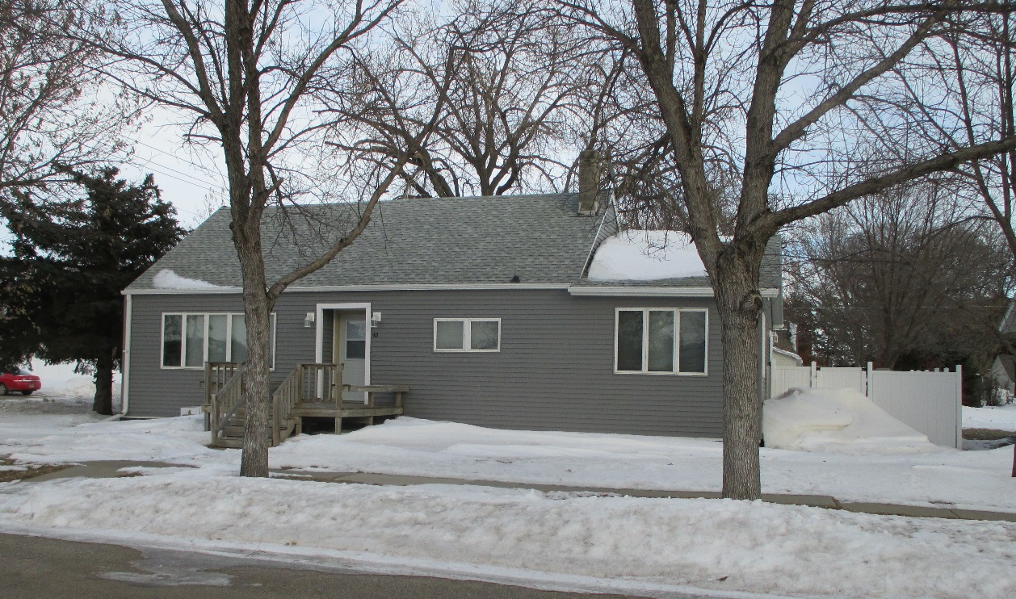
RECORD # 4358

LOT SIZE 75’ X 140’ GROUND FLOOR 1364 SQ FT
SINGLE FAMILY - 1 ½ STORY TOTAL AREA 1651 SQ FT
AVERAGE QUALITY & CONDITION 3 BEDROOMS 2 BATHS
BUILT IN 1955 BASEMENT 960 SQ FT
2015; ROOF FAIR, SIDING FAIR BASEMENT 480 SQ FT FIN REC
CENTRAL AIR, 3 SEASON PORCH DETACHED GARAGE 624 SQ FT
2018, 2 EGRESS, 2019 NEW FENCE WOOD DECK 323 SQ FT
SOLD ON 9/17/19 FOR $100,000 WOOD PORCH 86 SQ FT
ASSESSED IN 2019 $108,390
SOLD IN 2004 FOR $60,000 RECORD #4358

