$30,000.00
THORSTENSON – DEAL
5706 1ST AVE. SELBY
MILW LAND CO’S 1ST ADDN S 10’ OF LOT 2 & ALL LOT 3 BLOCK 21
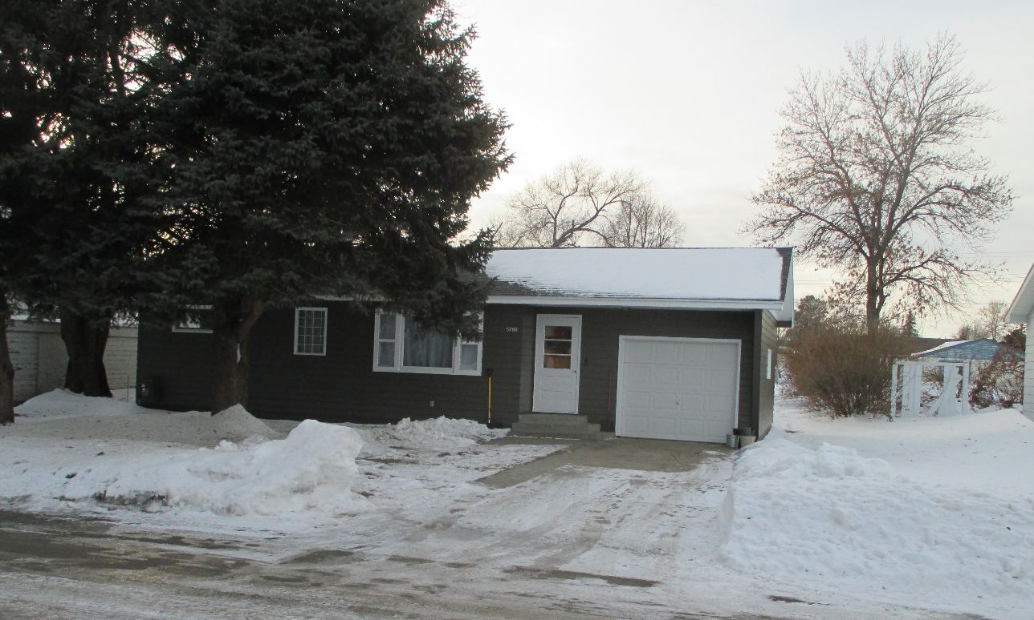
RECORD #4303

LOT SIZE 60’ X 140’ GROUND FLOOR 841 SQ FT
SINGLE FAMILY – ONE STORY 2 BEDROOMS 1 BATH
FAIR CONDITION & QUALITY ATTACHED GARAGE 263 SQ FT
BUILT IN 1956
NATURAL GAS, WINDOW AIR
2015; ROOF POOR, CHIMNEY BRICK POOR
2019; HOUSE PAINTED, NEW ROOF
SOLD ON 9/18/19 FOR $30,000
ASSESSED IN 209 AT $39,470
ASSESSED IN 2015 AT $25,965 RECORD #4303

