$1,000.00
SCHNAIBLE – STANGL
MILWAUKEE STREET, JAVA
MILW LAND CO’S 2ND ADDN N ½ LOT 8 & ALL LOTS 9 & 10 BLOCK 14
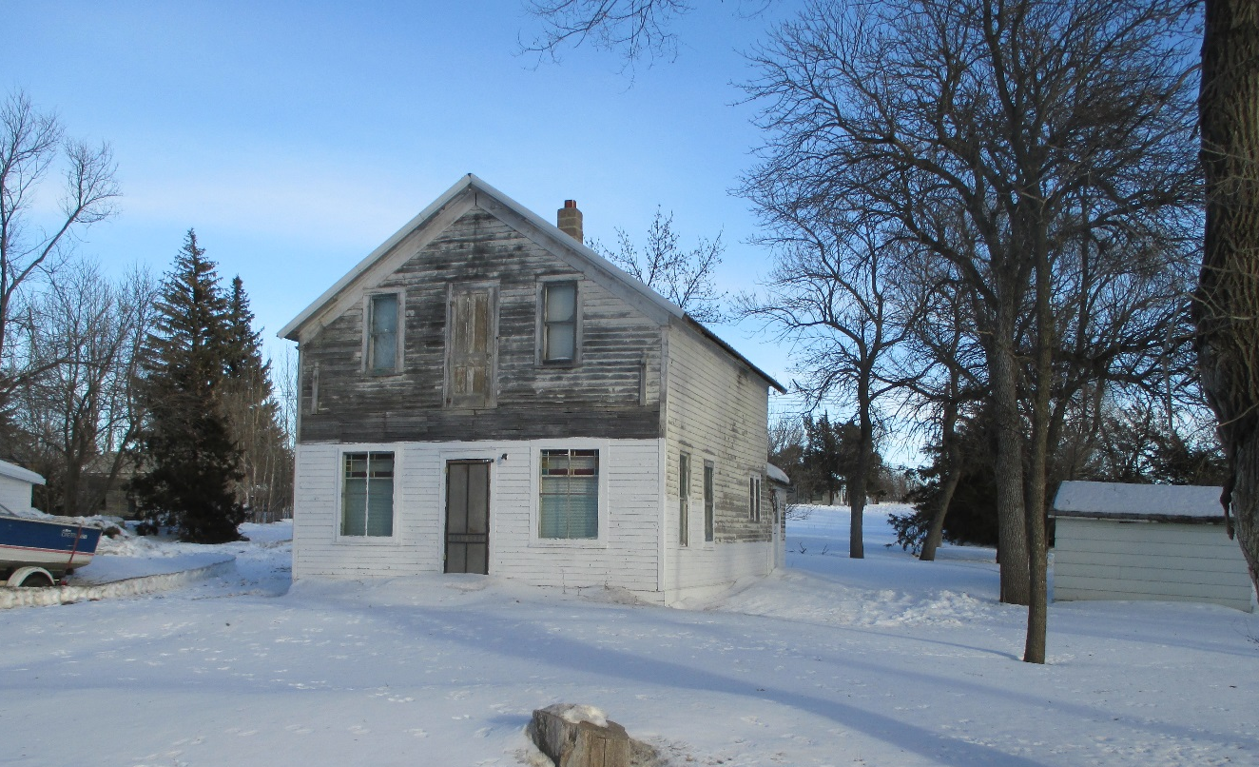
RECORD #4083

LOT SIZE 125’ X 140’ GROUND FLOOR 572 SQ FT
SINGLE FAMILY – 1 ½ STORY TOTAL AREA 858 SQ FT
BELOW AVERAGE QUALITY & CODITION NO BASEMENT
BUILT IN 1910 5 BEDROOMS
SOLD ON 12/2/19 FOR $1,000 1 BATH
ASSESSED IN 2019 AT $2,620 ATTACHED GARAGE 480 SQ FT
SOLD IN 2015 FOR $1,500
ASSESSED IN 2015 AT $2,385 RECORD #4083

