$8,000.00
SCHNAIBLE – GARDINER
4311 MAIN ST. JAVA
JAVA MILW LAND CO’S 1ST ADDN LOTS 5 & 6 BLOCK 11
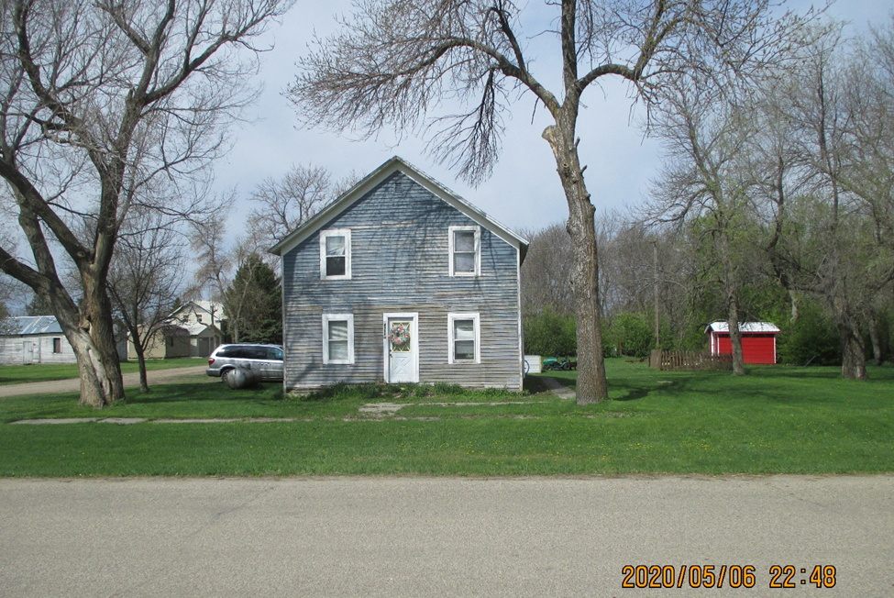
RECORD #4065

LOT SIZE 100’ X 140’ GROUND FLOOR 624 SQ FT
2 STORY - SINGLE FAMILY TOTAL AREA 1248 SQ FT
FAIR CONDITION 3 BEDROOMS
FAIR QUALITY SOLID WALL PORCH 112 SQ FT
BUILT IN 1890
1995; REMODEL INTERIOR
SOLD ON 2/24/2020 FOR $8,000
ASSESSED IN 2020 AT $2,420
SOLD ON 9/23/2014 FOR $2,200 (TAX DEED) RECORD #4065
ASSESSED IN 2015 AT $2,200

