$13,750.00
BENDER – THORSTENSON
6303 ST. PAUL STREET, JAVA
JAVA MILW LAND CO’S 1ST ADDN LOTS 1 & 2 BLOCK 9
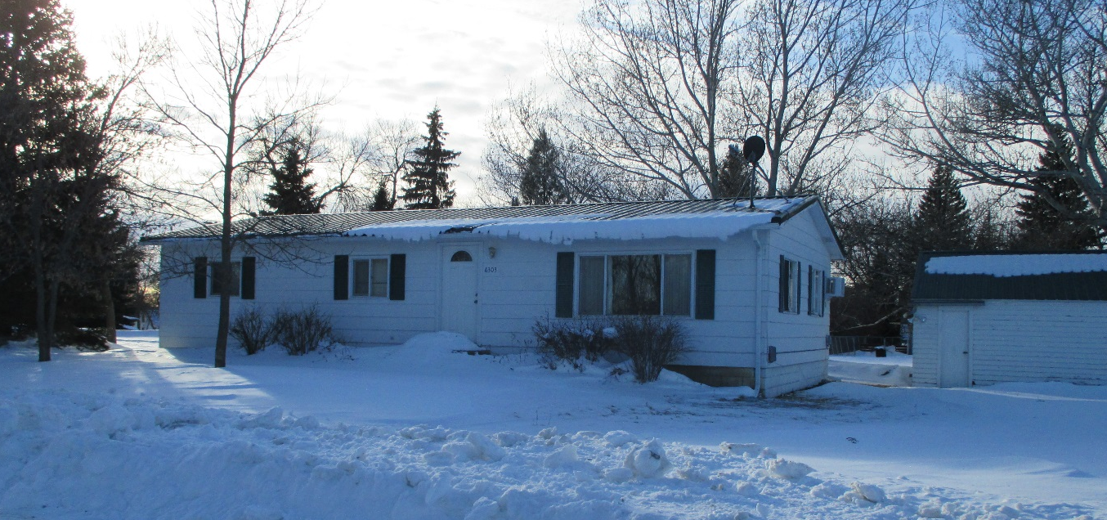
RECORD #4049

LOT SIZE 100’ X 140’ GROUND FLOOR 1152 SQ FT
SINGLE FAMILY – ONE STORY BASEMENT 1152 SQ FT
AVERAGE QUALITY & CONDITION 3 BEDROOMS
BUILT IN 1950 6 FIXTURES
SOLD ON 9/4/19 FOR $13,750 SOLID WALL PORCH 120 SQ FT
ASSESSED IN 2019 AT $15,620 (WD AUCTION)
ASSESSED IN 2014 AT $14,200 DETACHED GARAGE 572 SQ FT

RECORD #4049

