$150,000.00
SCHAFFER – HAMMRICH
09 SARAH SUE PLACE, JAVA
LOTS 18, 19, 20 & REPLAT OF LOT 21 SARAH SUE ADDN IN E2SW4 GOVT LOTS 3 & 4 IN 30 AND E2NW4 31 ALL IN 123-74
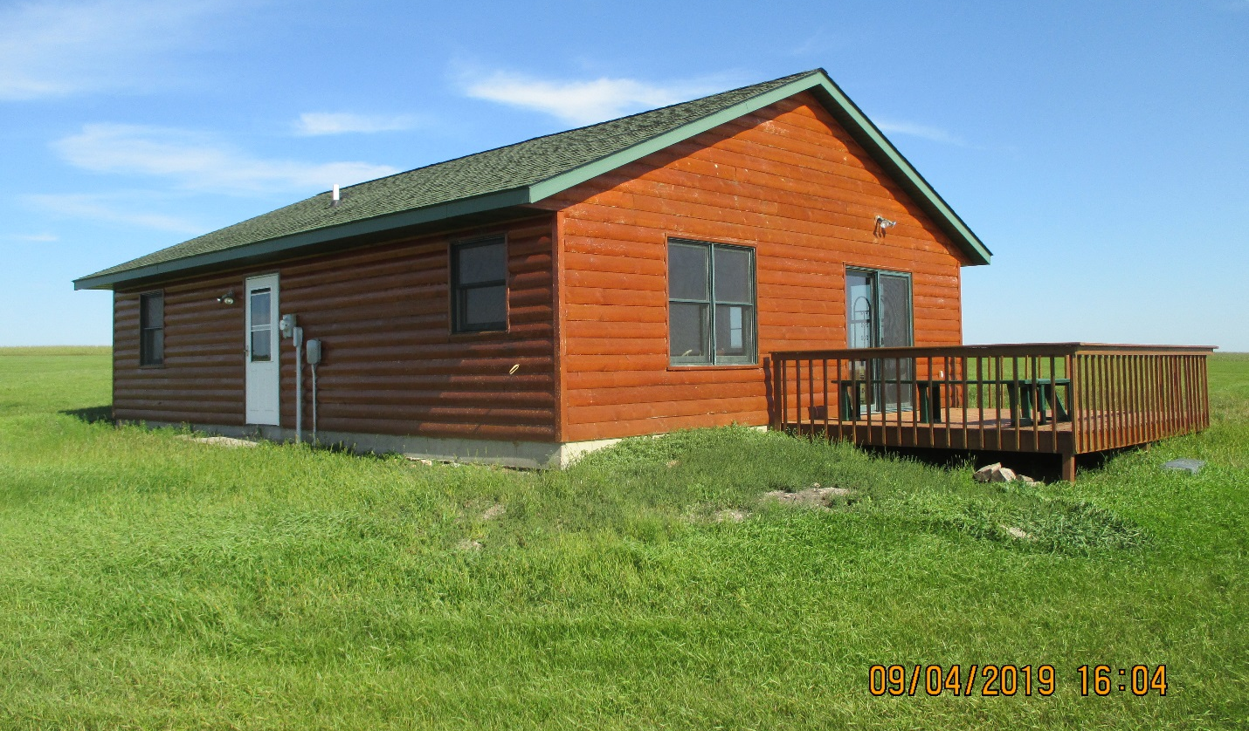
RECORD #8174

8.74 ACRES RECORD #8174
SINGLE FAMILY ONE STORY
AVERAGE QUALITY & CONDITION
BUILT IN 2008
TOTAL LIVING AREA 1064 SQ FT
WOOD DECK 144 SQ FT
5 FIXTURES 1 ROUGH IN
1 BATH 3 BEDROOMS
SOLD ON 6/21/19 FOR $150,000
ASSESSED IN 2019 AT $129,260 ASSESSED IN 2010 AT $84,675

