$215,000.00
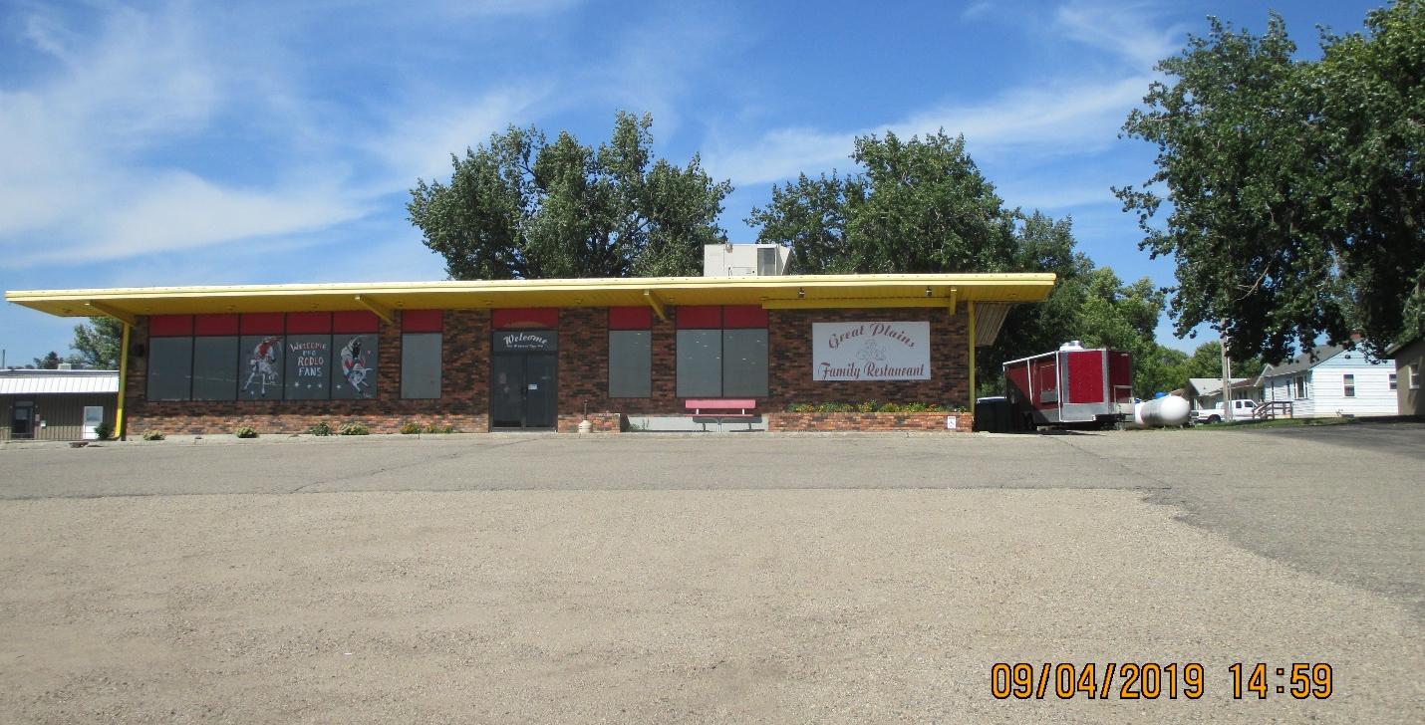
HUBER – GREAT PLAINS FAMILY REST. LLC
905 WEST GRAND CROSSING, MOBRIDGE
MOBRIDGE NWTS CO’S 3RD ADDN LOT 1 & PART OF LOTS 2, 3 & 9 NOT TAKEN BY HWY BLOCK 43
RECORD #6211

LOT SIZE 257.1 X 150.61
100 % RESTAURANT
5340 SQ FT
BUILT IN 1977
RECENT INTERNAL REMODEL
BRICK FACADE
AVERAGE CONDITION & QUALITY
METAL FRAME AND WALLS RECORD #6211

