$101,000.00
ANDERSON – DYKHOUSE
614 11TH ST WEST, MOBRIDGE
NWTS 2ND ADDN LOT 9 & S 6’ OF LOT 10 BLOCK 19
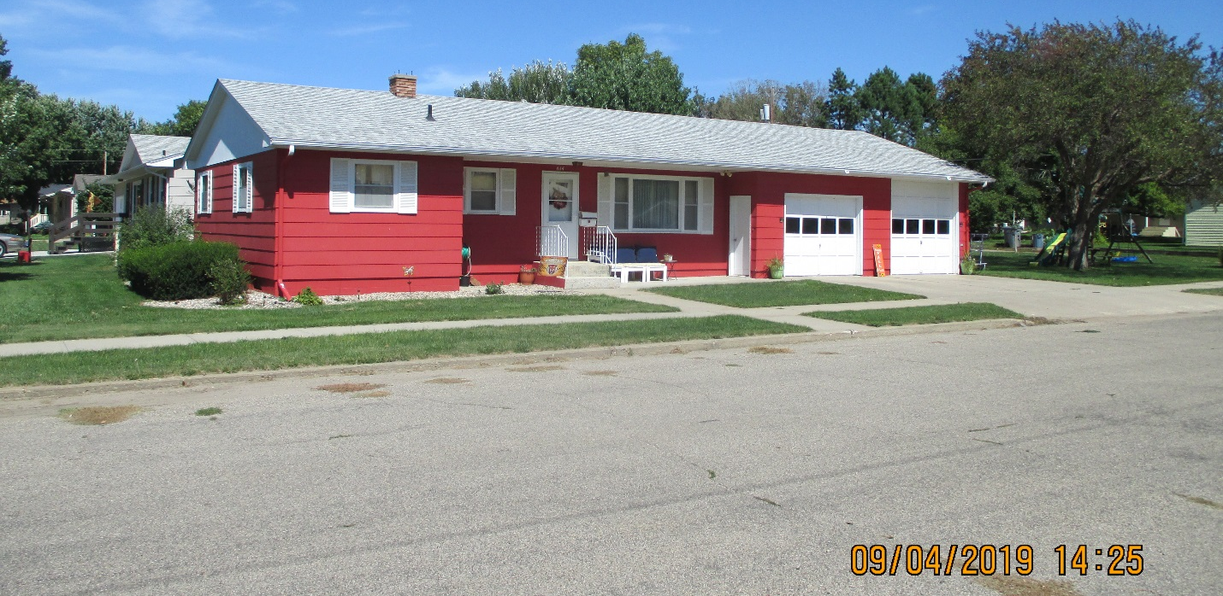
RECORD #6049

LOT SIZE 52’ X 140’ LIVING AREA 1066 SQ FT
SINGLE FAMILY ONE STORY 3 BEDROOMS ABOVE 1 BELOW
AVERAGE QUALITY & CONDITION 1 FULL BATH, ¾ BATH, ½ BATH
BUILT IN 1965 BASEMENT 1066 SQ FT
2014; ROOF GOOD, SIDING GOOD 533 SQ FT FIN. REC. IN BSMT
CENTRAL AIR, NATURAL GAS, WINDOWS FAIR
SOLD ON 12/18/18 FOR $101,000 ROOFED PORCH 104 SQ FT
ASSESSED IN 2019 AT $92,980 ATTACHED GARAGE 810 SQ FT
SOLD ON 8/02/18 FOR $103,000
SOLD ON 10/27/15 FOR $96,000
ASSESSED IN 2012 AT $72,125
ASSESSED IN 2010 AT $69,545 RECORD #6049

