$43,500.00
WEST – BARZ
916 1ST AVE WEST
MOBRIDGE MAIN PARK LOT 16 BLOCK 19
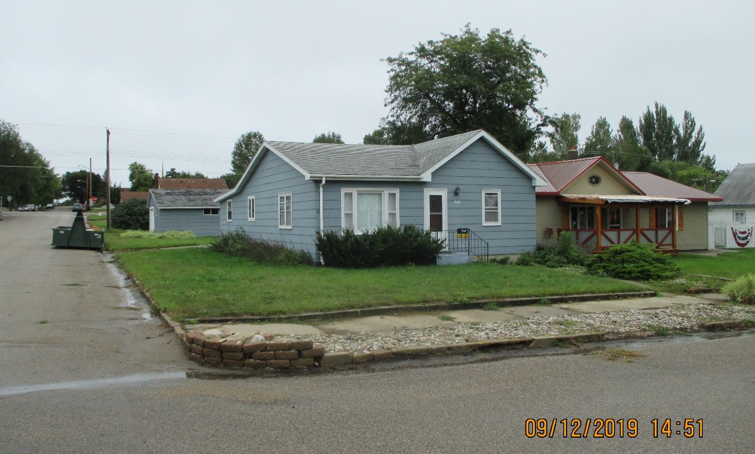
RECORD #5678

LOT SIZE 37.5’ X 142’ TOTAL GROUND FLOOR 1268 SQ FT
ONE STORY SINGLE FAMILY 2 BEDROOMS 1 ½ BATHS
AVERAGE QUALITY & CONDITION COVERED PORCH 128 SQ FT
BUILT IN 1920 DETACHED GARAGE 506 SQ FT
2014; SOME NEWER WINDOWS
GARAGE TURNED INTO LIVING
NATURAL GAS CENTRAL AIR
1990; 10’ X 22’ ADDN TO GARAGE
SOLD ON 7/08/19 FOR $43,500
ASSESSED IN 2019 AT $48,830
ASSESSED IN 2014 AT $41,690 RECORD #5678

