$165,000.00
SALZSIEDLER – TABBERT
1013 NORTH MAIN, MOBRIDGE
MOBRIDGE MAIN PARK LOT 2 & N ½ OF LOT 3 BLOCK 18
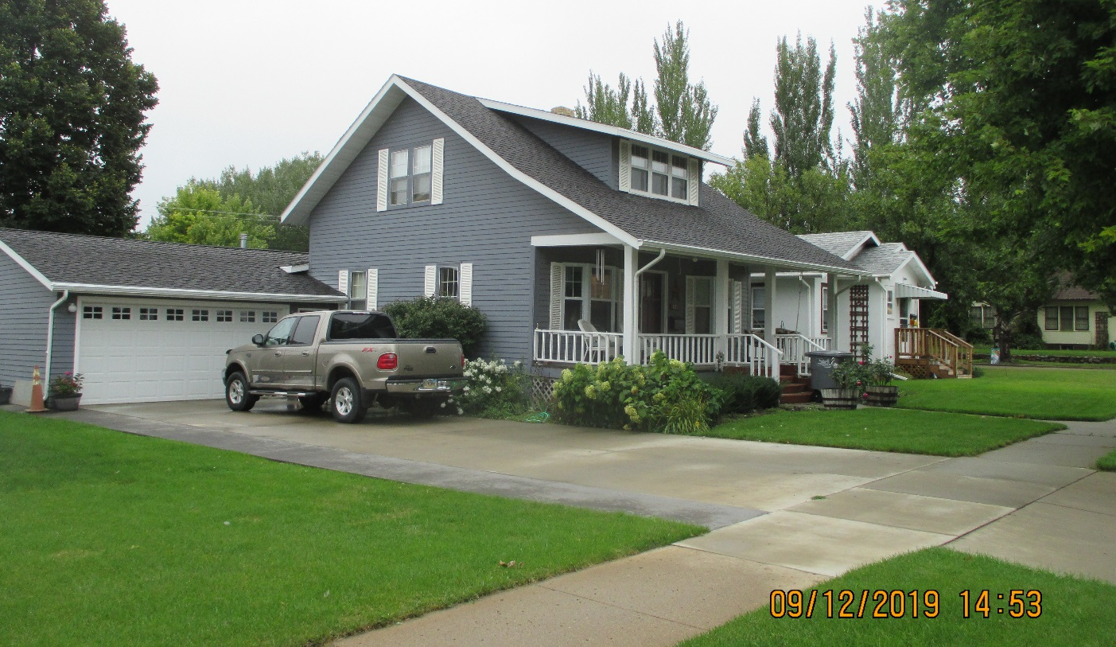
RECORD #5660

LOT SIZE 56.25’ X 152’ GROUND FLOOR 1268 SQ FT
SINGLE FAMILY 1 ½ STORY TOTAL AREA 1632 SQ FT
AVERAGE QUALITY & CONDITION 3 BEDROOMS 2 FULL BATHS
BUILT IN 1930 2 ¾ BATHS 1 FIREPLACE
2014; 2 BAY WINDOWS, WOOD DECK BASEMENT 728 SQ FT
DORMER ON EAST, 3 SEASON PORCH WEST ATTACHED GARAGE 528 SQ FT
2 CENTRAL AIR UNITS, OLDER WINDOWS GOOD
LARGE WOODEN DECK WITH SLIDING GLASS ROOFED PORCH 224 SQ FT
SOLD ON 2/01/2019 FOR $165,000 WOOD DECK 384 SQ FT
ASSESSED IN 2019 AT $142,110 15’ X 17’ STORAGE SHED
ASSESSED IN 2012 AT $64,435
RECORD #5660

