$33,000.00
FRAILING – MCCLELLAN
416 4TH ST. WEST, MOBRIDGE
MOBRIDGE GRAND CROSSING ADDN. LOT 7A, BLOCK 29 (E ½ LOT 7)
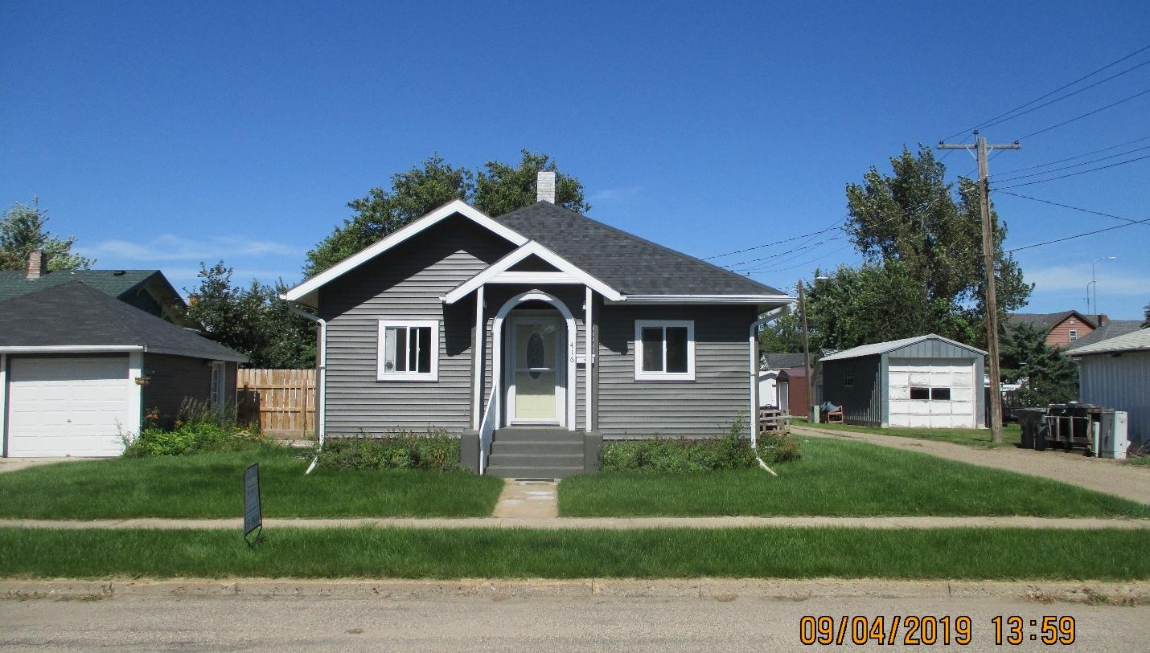
RECORD #5224

LOT SIZE 50’ X 70’ TOTAL LIVING AREA 780 SQ FT
SINGLE FAMILY – ONE STORY 2 BEDROOMS 1 ½ BATH
AVERAGE QUALITY & CONDITION BASEMENT 780 SQ FT
BUILT IN 1920 DETACHED GARAGE 240 SQ FT
2015; ROOF POOR GARAGE SHARED WITH NEIGHBOR
WOOD WINDOWS FAIR, FUEL OIL CONCRETE PATIO IN REAR
2019; 90 % GUT OF INTERIOR, FLOORS, DRYWALL
CEILING ETC. $20,000
SOLD ON 10/19/18 FOR $33,000
ASSESSED IN 2018 AT $21,070; 2019 AT $21,070 RECORD #5224
SOLD IN 2005 FOR $10,500
ASSESSED IN 2012 AT $16,985; 2005 AT $15,916

