$20,000.00
HUBBARD – OLSEN
106 4TH AVE EAST, MOBRIDGE
MOBRIDGE EKLO’S 1ST ADDN., LOT 8 BLOCK 4
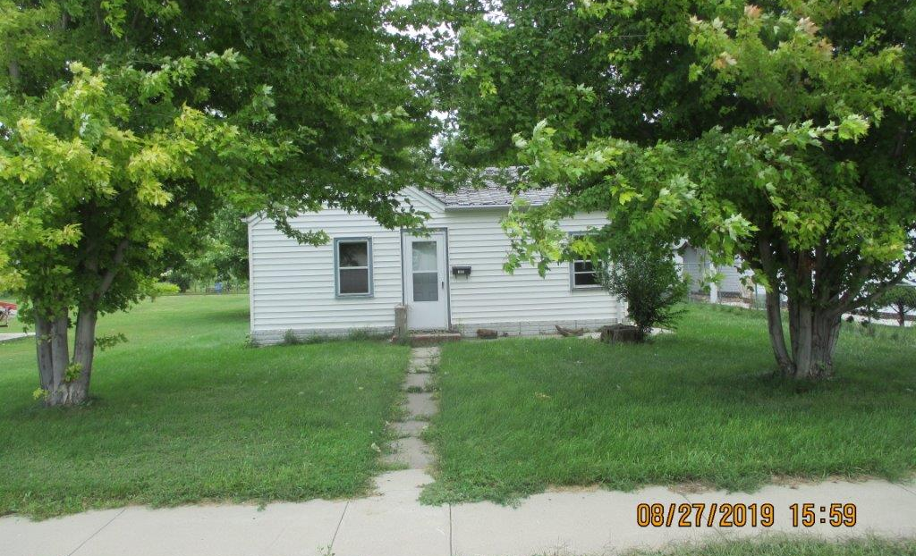
RECORD #4923

LOT SIZE 50’ X 140’ TOTAL LIVING 628 SQ FT
SINGLE FAMILY ONE STORY 2 BEDROOMS ABOVE 1 BELOW
NORMAL QUALITY & CONDITION 1 BATH
BUILT IN 1908 BASEMENT 110 SQ FT
2010; UPGRADE KITCHEN & LAUNDRY PLMB.
2014; VINYL SIDING, ALUMINUM STORM/SCREEN
PROPANE, FLAT ROOF GARAGE
SOLD ON 5/17/19 FOR $20,000 ATTACHED GARAGE 240 SQ FT
ASSESSED IN 2019 AT $19,150 10’ X 22’ SUNPORCH
SOLD IN 2003 FOR $15,000
ASSESSED IN 2012 AT $11,955 RECORD #4923

