$167,500.00
RUEB – MARSHALL
110 WEST TOWER, SELBY
SELBY PLAINVIEW 1ST, LOTS 1 & 2 BLOCK 9, SELBY
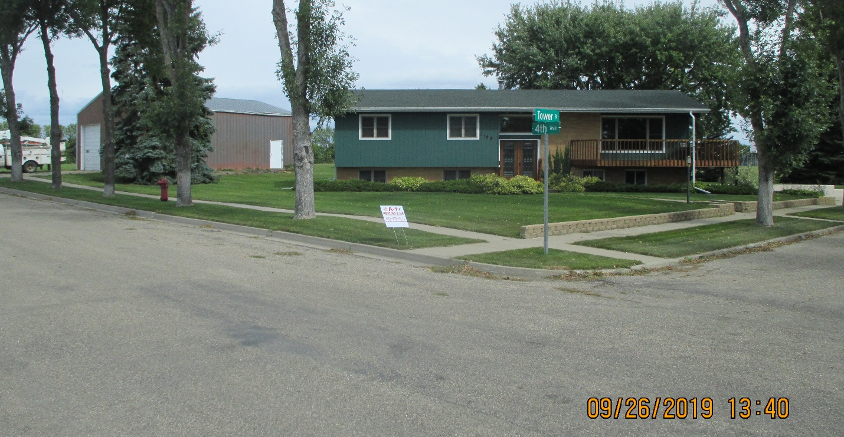
RECORD #4633

LOT SIZE 159’ X 140’ GROUND FLOOR 1590 SQ FT
SINGLE FAMILY ONE STORY 3 BEDROOMS 2 ½ BATHS
AVERAGE QUALITY & CONDITION BASEMENT 924 SQ FT LIVING
BUILT IN 1968 BUILT IN GARAGE 616 SQ FT
2015; BRICK FACE, SPLIT LEVEL WOOD DECK 284 SQ FT
TUCK UNDER GARAGE, WOOD DECK WINDOWS REPLACED IN 2010
3 SEASON SCREENED GAZABO EAST 36’ X 40’ STEEL BUILDING
NATURAL GAS CENTRAL AIR
SOLD ON 6/14/19 FOR $167,500
ASSESSED IN 2019 AT $110,010
ASSESSED IN 2012 AT $53,765 RECORD #4633

