$15,000.00
O’LEARY – HOLDER
2806 LINCOLN, SELBY
SELBY OVERHOLSERS ADDN LOT 10 & S ½ OF LOT 11 BLOCK 6
RECORD #4583
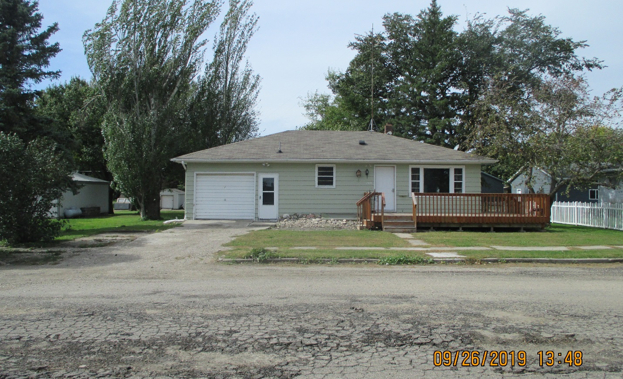

LOT SIZE 75’ X 140’ GROUND FLOOR 884 SQ FT
ONE-STORY SINGLE-FAMILY BASEMENT 884 SQ FT
AVERAGE QUALITY & CONDITION 600 SQ FT FINISHED IN BSMT
BUILT IN 1958 2 BEDROOMS ABOVE 2 BELOW
2015; ROOF GOOD, EGRESS EAST 2 FULL BATHS I SINGLE FIX. ROOM
NATURAL GAS CENTRAL AIR ATTACHED GARAGE 260 SQ FT
ALUM/WOOD WINDOWS FAIR 2016; L-SHAPED DECK $5,000
SOLD ON 12/31/18 FOR $15,000 1998 BASEMENT FINISH $4,000
ASSESSED IN 2019 AT $47,960
SOLD IN 2013 FOR $45,000
ASSESSED IN 2013 AT $33,670 RECORD #4583

