$160,000.00
OPHEIM – BERENS
4503 3RD AVE, SELBY
SELBY ORIGINAL N ½ LOT 8 & ALL LOT 9 BLOCK 2
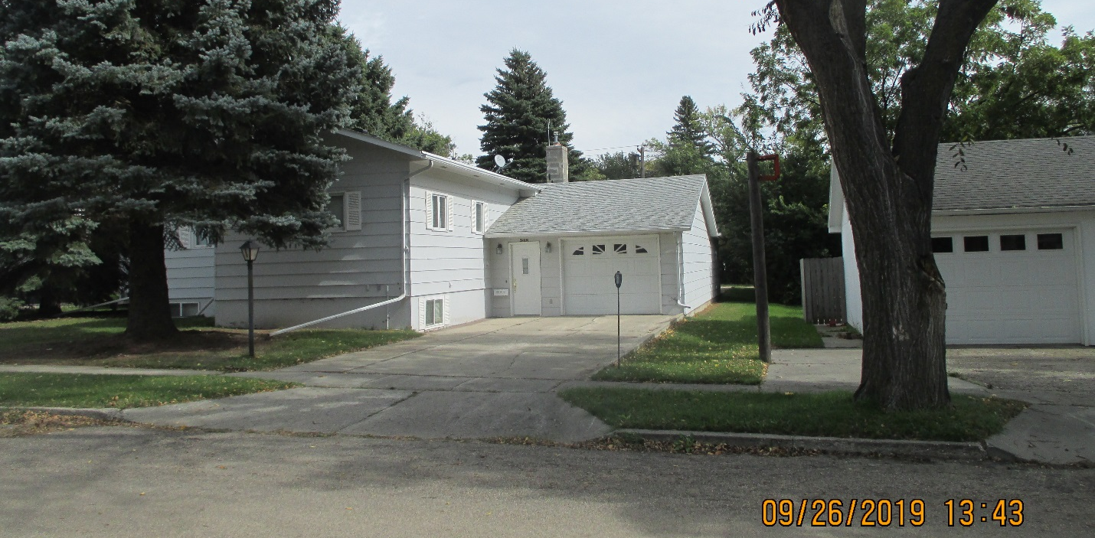
RECORD #4412

LOT SIZE 75’ X 140’ GROUND FLOOR 1476 SQ FT
SINGLE-FAMILY ONE-STORY BASEMENT 1404 SQ FT
AVERAGE QUALITY & CONDITION 1300 SQ FT FINISHED BSMT
BUILT IN 1920 2 FULL BATHS
2015; LARGE BASEMENT WINDOWS 1978 NEW BASEMENT
DRIVE THRU ATTACHED GARAGE GARAGE 864 SQ FT
ROOF GOOD, CENTRAL AIR WOOD DECK 173 SQ FT
SOLD ON 8/13/19 FOR $160,000
ASSESSED IN 2019 AT $76,120
ASSESSED IN 2014 AT $53,770 RECORD #4412

