$80,500.00
MARSHALL – FUHRER
3102 6TH AVE. SELBY
SELBY – MILW OUTLOTS, LOT 1 OF OUTLOT D, N. 75’ OF S. 150’ OF E. 178.025’
RECORD #4389
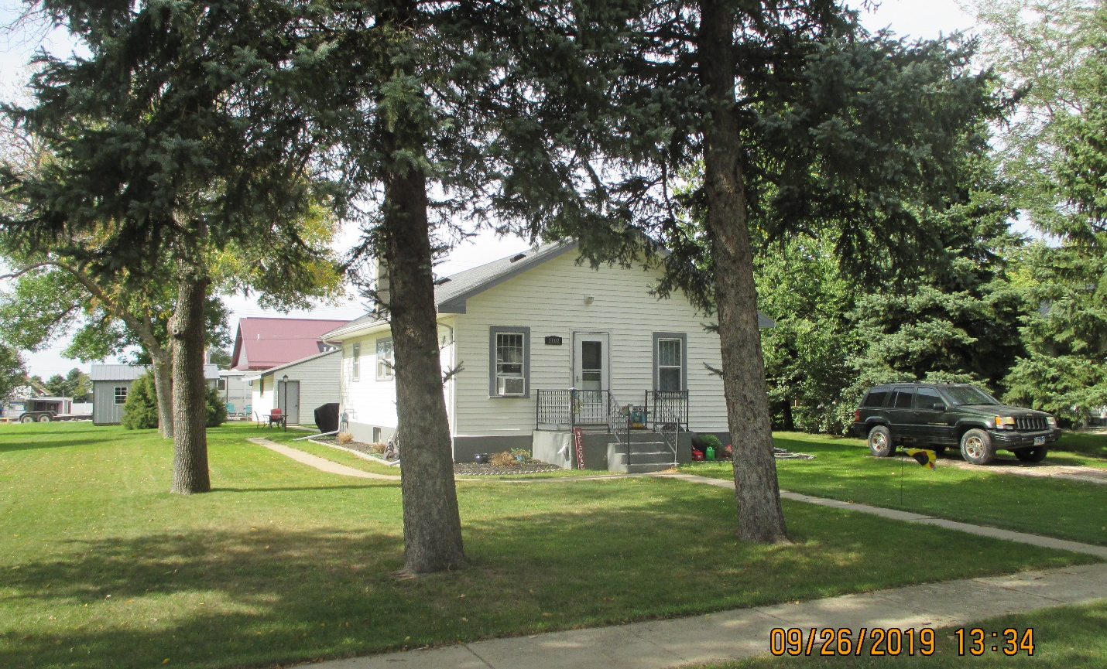
LOT SIZE 75’ X 178.025’ GROUND FLOOR 864 SQ FT
SINGLE FAMILY – ONE STORY 2 BEDROOMS 2 BATHS
AVERAGE QUALITY & CONDITION BSMT 864 SQ FT, 345 SQ FT FIN REC
BUILT IN 1912 FULL BATHROOM IN BASEMENT
2015; ROOF GOOD, NATURAL GAS DETACHED GARAGE 672 SQ FT
CENTRAL AIR, LARGE BSMT WINDOWS NEWER SOLID WALL PORCH 36 SQ FT
2016; REMODEL $1,000; REMODEL BSMT $10,000
2017; 12’ X 24’ SHED $5,500 OPEN SLAB PORCH 156 SQ FT
SOLD ON 6/19/19 FOR $80,500
ASSESSED IN 2019 AT $51,130 RECORD #4389
SOLD IN 2016 FOR $55,000; ASSESSED IN 2014 AT $21,470

