$44,000.00
THORSTENSON – ROEBUCK
206 SCRANTON, SELBY
SELBY MILW LAND CO’S 1ST ADDN W ½ OF LOTS 4,5 & 6 BLOCK 22
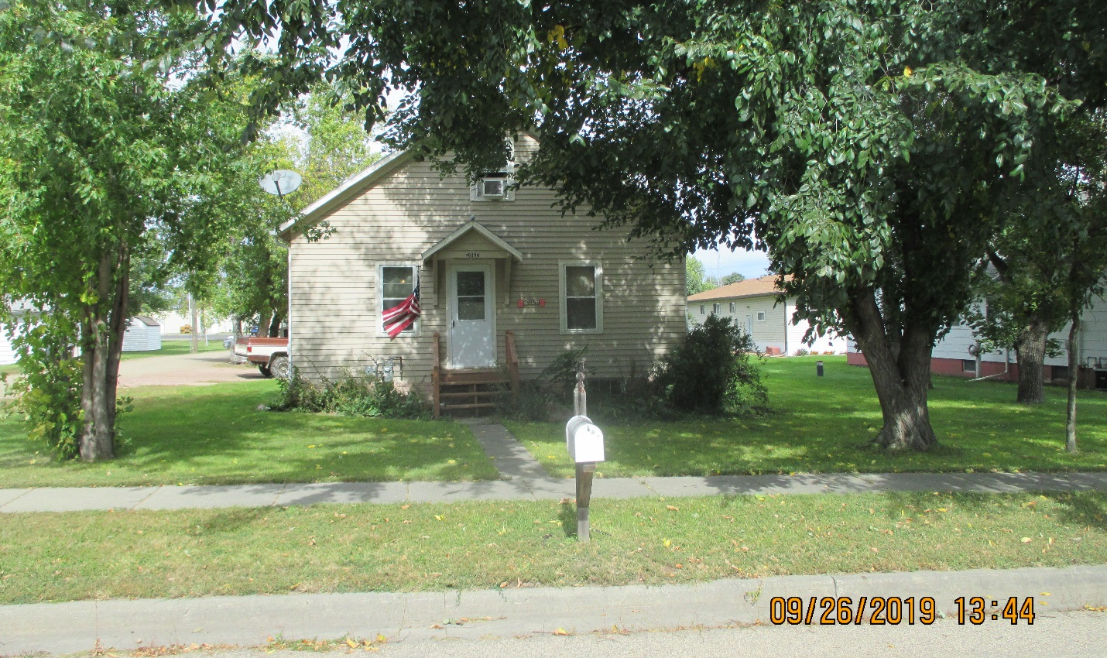
RECORD #4313

LOT SIZE 70’ X 150’ GROUND FLOOR 780 SQ FT
SINGLE-FAMILY ONE-STORY TOTAL AREA 1014 SQ FT
FAIR QUALITY & CONDITION 2 BEDROOMS 1 BATH
BUILT IN 1920 BASEMENT 780 SQ FT
2015; ROOF GOOD, SIDING FAIR DETACHED GARAGE 280 SQ FT
ALUM/WOOD FAIR SOLID WALL PORCH 81 SQ FT
SOLD ON 6/04/19 FOR $44,000 2001 6’ X 20’ GARAGE ADDITION
ASSESSED IN 2019 AT $37,350
SOLD IN 2017 FOR $35,000
ASSESSED IN 2015 AT $29,490
SOLD IN 2006 FOR $19,000
ASSESSED IN 2006 AT $9,473 RECORD #4313

