$20,000.00
SCHNAIBLE – YILDRIM
4222 MAIN ST. JAVA
JAVA ORIGINAL LOT 7 BLOCK 5
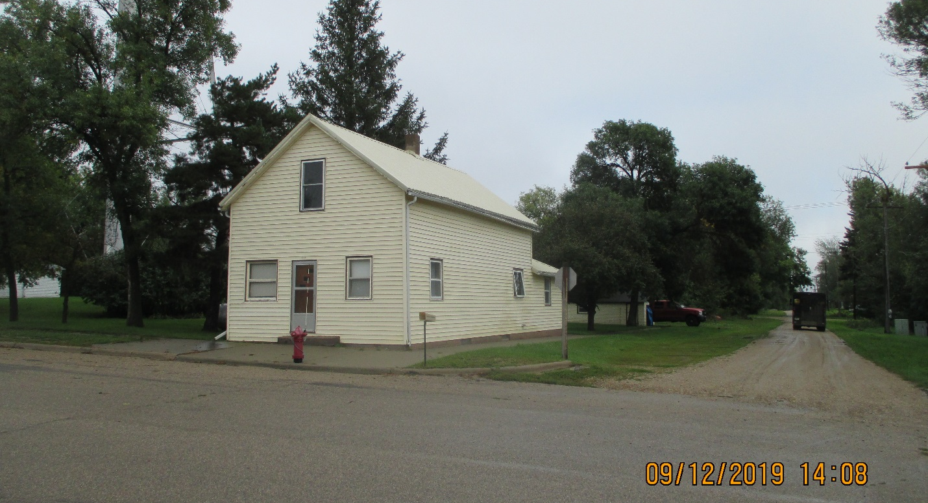
RECORD #4016

LOT SIZE 25’ X 140’ GROUND FLOOR 888 SQ FT
SINGLE – FAMILY TWO – STORY TOTAL LIVING AREA 1439 SQ FT
AVERAGE QUALITY & CONDITION 3 BEDROOMS 1 BATH
BUILT IN 1910 BASEMENT 720 SQ FT
SOLD ON 7/31/2019 FOR $20,000 DETACHED GARAGE 280 SQ FT
ASSESSED IN 2019 AT $17,340
ASSESSED IN 2014 AT$15,765 RECORD # 4016

