$210,000.00
LANG HOCHHALTER – POLZEN
28774 HWY 12 EAST, MOBRIDGE
LOT 9 GOETZ ADDN IN S2SE4 21-124-79
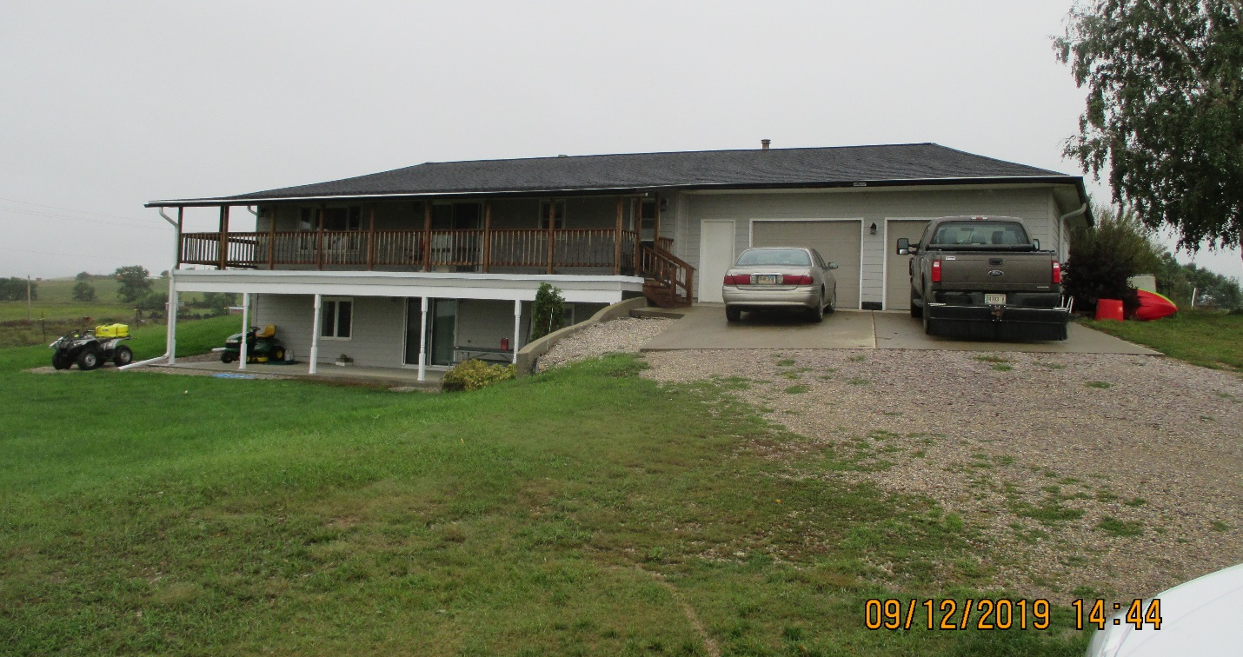
RECORD #3669

3.77 ACRES GROUND FLOOR 1288 SQ FT
SINGLE FAMILY ONE STORY 3 BEDROOMS 2 BATHS
AVERAGE QUALITY & CONDITION WALKOUT BASEMENT 1288 SQ FT
BUILT IN 1965 ATTACHED GARAGE 728 SQ FT
2015; ROOF GOOD, OLD ROUND QUONSET BASEMENT FINISHED
CENTRAL AIR, NATURAL GAS WOOD UTILITY SHED
WALKOUT BASEMENT, COVERED SLAB
SLIDING GLASS, COVERED WOOD DECK
SOLD ON 7/01/2019 FOR $210,000
ASSESSED IN 2019 AT $138,450
SOLD IN 2010 FOR $57,500
ASSESSED IN 2012 $83,115 RECORD #3669

