$107,000.00
HUBER – WEINERT
TRACT 1 HUBER ADDN IN W2NW4NW4 AKA GOVT LOT 4
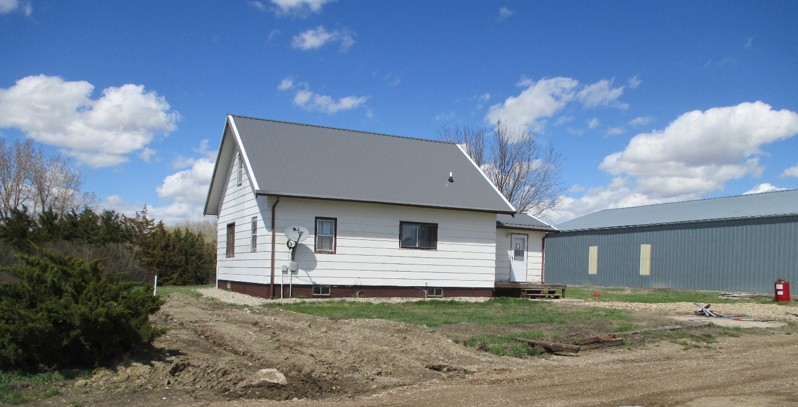
RECORD #8884

10.26 ACRES TOTAL LIVING 1422 SQ FT
SINGLE FAMILY – 1 ½ STORY 1ST FLOOR AREA 1032 SQ FT
AVERAGE QUALITY & CONDITION 40’ X 80’ MACHINE SHED
BUILT IN 1925 48’ X 64’ MACHINE SHED
SOLD ON 3/29/19 FOR $107,000 20’ X 40’ SHED
ASSESSED IN 2019 AT $51,730 OTHER BINS & SHEDS
2000; BASEMENT HALF FINISHED
1 BEDROOM MAIN, 2 UPSTAIRS RECORD #8884

